**Food Deserts in US in Association with Socioeconomic Factors and Related Health Conditions**

Meghana Bibireddy, Rathnapriya Gopalakrishnan, Sri Rama Teja Makineedi, Patrick Page, Latha Sree Rayala, and Sriha Yalamanchi

Indiana University-Purdue University, Indianapolis, IN 46202, USA

[mebibi@iu.edu](mailto:mebibi@iu.edu), [rgopala@iu.edu](mailto:rgopala@iu.edu), [smakine@iu.edu](mailto:smakine@iu.edu), [patpage@iu.edu](mailto:patpage@iu.edu), [lrayala@iu.edu](mailto:lrayala@iu.edu), [sriyala@iu.edu](mailto:sriyala@iu.edu).

**Abstract:** Our project goal is to analyze the association of Food Deserts in relation to socioeconomic factors and health conditions.Through this study we have identified the relationship of food deserts with respect to states having higher minority population ,with higher percentage of people with diabetes, high cholesterol, obesity and cardiovascular diseases, with areas lacking transport facilities causing increased health issues and does low income and high poverty rate areas are associated with food deserts .This project will make people aware of food deserts and lead to the establishment of new grocery and food stores in food desert areas to give nutritious food supplies to those in need.

**Keywords:** Food Deserts, food apartheid, low food access ,povery, lowincome, health conditions, socioeconomic factors,minoritiy populations, food supplies.

**1 PROJECT SCOPE**

**1.1 INTRODUCTION**

More than 2 million people in the US do not have accessibility to grocery stores [1]. This means that a large percentage of American citizens lack the opportunity to eat fresh, healthy foods. These areas of communities that do not have easy access to the grocery stores are known as food deserts. Food deserts share many socioeconomic characteristics. Food deserts are typically found in impoverished neighborhoods and are predominantly composed of black and brown communities.

**1.2 AIM**

The aim of the study is to determine the associations between socioeconomic factors, the geographic locations of food deserts, and the unproportional percentages of cardiovascular diseases amongst black and brown populations compared to white populations. To help determine these associations, the following research questions have been posed:

1. Are food deserts more prevalent in counties that have higher populations of minorities?
2. Do food deserts result in higher percentages of people living with diabetes, high-cholesterol, obesity and cardiovascular diseases?
3. Does lacking a vehicle and living in a food desert increase risk of becoming unhealthy?
4. Do people that live in low-income and high poverty rate communities have a greater chance of living in a food desert?

The null hypothesis for each research question are below:

1. Food deserts are not more prevalent in areas that contain higher populations of minorities.
2. Food deserts do not contribute to increased percentages of diabetes, high-cholesterol, obesity or cardiovascular diseases.
3. Not having a vehicle and living in a food desert does not increase risk of becoming unhealthy.
4. People that live in low-income communities do not have a greater chance of living in a food desert.

**1.3 PURPOSE**

The purpose of the study is to better understand the connections between food deserts and socioeconomic factors as well as to understand the devastating effects food deserts have on the overall health of the people that live in them. The term food deserts is relatively unknown amongst the majority of Americans that do have access to grocery stores and fresh, healthy foods. It’s important for people to understand what a food desert is and to see the inequalities of accessible food in America. Hopefully, if the awareness of food deserts increases, more outreach will be made to provide better food sources to communities that need it most.

**2 METHODOLOGY**

**2.1 STEPS OF THE PROJECT**

The main goal of our project is to find if food desserts have associations with Health Conditions, Socioeconomic factors, Transportation facilities, races in the United States. We did this by using database technologies such as SQL and python by using the tools phpMyAdmin, Python Jupyter Notebook, MySQL.

The Methodology of our project follows six steps, which includes:

1. Determine reliable data by making sure all of the data comes from credible sources, then saving the data as CSV files.
2. Prep the database for data by importing SQL code that creates our table and creates all the columns with appropriate data types.
3. Extract data and store data in the SQL database by creating a python script that reads the data in pandas dataframes and then writes the data into SQL using insert statements.
4. Cleaning data in pandas dataframes ensuring there are no longer null values.
5. Visualize and Analyze data by testing normalities and correlations. Statistical tests will also be performed to determine whether or not to reject the null hypothesis.
6. Build predictive models using a variety of regression models and classification models.
7. Develop conclusions based on the statistical tests and determine whether predictive models are effective in classifying food desserts.

**2.2 TEAM MEMBERS AND CONTRIBUTIONS:**

The table below shows the backgrounds and contributions of everyone on the team. Work was split between members based on their strengths and academic backgrounds.

| **NAME** | **BACKGROUND** | **CONTRIBUTIONS** |
| --- | --- | --- |
| Meghana Bibireddy | Bachelors of dental surgery | Data collection ,cleaning ,data visualization, and making powerpoint presentation. |
| Rathnapriya Gopalakrishnan | B.E in Computer Science and Engineering. Experience in Python and SQL | Data Cleaning, Data Visualizations- choropleth maps, Predictive Modeling and Evaluation, making powerpoint presentation, Presentation (presenter) |
| Sri Rama Teja Makineedi | Pharm D ( Doctor of Pharmacy) | Data collection and cleaning , Data forecasting |
| Patrick Page | B.S in Mechanical Engineering, Digital Manufacturing Engineer since 2019, experience with Python, Matlab, SQL, PowerBI | Project proposal, SQL code for table creation, data import script,data analysis, statistical testing, making powerpoint presentation.,presentation (presenter) |
| Latha Sree Rayala | Bachelor's Of Dental Surgery | Data collection and cleaning |
| Sriha Yalamanchi | Bachelor's Of Dental Surgery | SQL and Python coding, Data Analysis and Data Visualization,making powerpoint presentation, Presentation (presenter) |

**2.3 PROJECT CHALLENGES**

During our project, we encountered a few difficulties. We were debating whether we should discover connections and perform model analysis for all of the food deserts columns and the other columns, or should we analyze our data in some other way. After having a Teaching Assistant session, we decided to analyze the association of food desserts with the other variables by taking the two most common states that fall in the top ten after sorting out the states that are least healthy and have poor socioeconomic factors, and then checking the population of blacks and whites in these two unhealthy states. We categorized the states based on socioeconomic and health-related characteristics (as our purpose clearly states that we are trying to understand the connection between food deserts and socioeconomic factors, also the connection between food deserts and health conditions). After sorting, we came up with Alabama, Mississippi, and West Virginia as the top ten, and we used these states as our category to see whether there were any food deserts. Writing certain codes was quite challenging for few of us since we come from a science background.

**3 DATA COLLECTION**

In order to find the relationships between food deserts, overall wellbeing, and socio-economic factors, we decided to collect data from 3 different sources. The first source of data we collected from was the Food Access Research Atlas from 2019[2]. This dataset was compiled by the U.S. Department of Agriculture’s Economic Research Service. Estimates within the Atlas are “based on a 2019 list of supermarkets, the 2010 Decennial Census, and the 2014-2018 American Community Survey”[2]. The Atlas uses 3 main principles to assess a tract, partition of a US county, as a food desert. First, the Atlas provides information about the accessibility of grocery stores or alternative healthy food sources. This is measured by distance or by quantity. Second, the Atlas includes data about individual capability to access healthy food, like family income levels and vehicle availability. Lastly, the Atlas determines if the wider community can help an individual gain access to healthy food through the use of public transportation or other monetary means. So from the Food Access Research Atlas, we decided to collect the following:

* State
* County
* LATracts_1And10 - Flag for low-income and low access when considering low accessibility at 1 and 10 miles
* LATracts_halfAnd10 - Flag for low-income and low access when considering low accessibility at .5 and 10 miles
* LATracts_1And20 - Flag for low-income and low access when considering low accessibility at 1 and 20 miles
* LowIncomeTracts - Flag for low income tract
* PovertyRate - Share of the tract population living with income at or below the Federal poverty thresholds for family size
* MedianFamilyIncome - Tract median family income
* Lahunv10 - Housing units without vehicle count beyond 10 miles from supermarket
* Lahunv20 - Housing units without vehicle count beyond 20 miles from supermarket

Next, we needed to find a reliable data source to better understand health related issues that could potentially plague a community that is also considered a food desert. For this data, we used the Interactive Atlas of Heart Disease and Stroke from the Center of Disease Control and Prevention (CDC)[3]. This Atlas was compiled from heart disease and stroke data sourced from the Deaths National Vital Statistics System and hospitalization discharge statuses along with stroke risk factors that were sourced from the Division of Diabetes Translation (estimations) and from PLACES (model-based estimations). From the Atlas of Heart Disease and Stroke, we decided to collect the following risk factors to evaluate the overall health of US counties:

* Obesity, Age-Adjusted Percentage, 20+, 2017 (columns)
  + County
  + State
  + Value
* Diagnosed Diabetes, Age-Adjusted Percentage, 20+, 2017 (columns)
  + County
  + State
  + Value
* High Cholesterol Among Adults Screened in Past 5 Years Aged 18+, 2017
  + County
  + State
  + Value
* Total Cardiovascular Disease Death Rate per 100,000, All Ages, Black (Non-Hispanic), Both Genders, 2017-2019
  + County
  + State
  + Value
* Total Cardiovascular Disease Death Rate per 100,000, All Ages, Hispanic, Both Genders, 2017-2019
  + County
  + State
  + Value 15
* Total Cardiovascular Disease Death Rate per 100,000, All Ages, White (Non-Hispanic), Both Genders, 2017-2019
  + County
  + State
  + Value 16

Lastly, we needed to collect data to give us a better idea of the social-economics of each US county. We found helpful data from the U.S. Census bureau to accomplish this. From the census data, we utilized the 2021 Annual Social and Economic Supplements [4] along with the Educational Attainment Supplement [5]. We collected the following data from these two Census supplements:

* Name - Geographic Area Name
* P1_001N - !!Total:!!Population of one race
* P1_003N - !!Total:!!Population of one race:!!White alone
* P1_004N - !!Total:!!Population of one race:!!Black or African American alone
* S1501_C01_001E - Estimate!!Total!!AGE BY EDUCATIONAL ATTAINMENT!!Population 18 to 24 years
* S1501_C01_002E - Estimate!!Total!!AGE BY EDUCATIONAL ATTAINMENT!!Population 18 to 24 years!!Less than high school graduate
* S1501_C01_003E - Estimate!!Total!!AGE BY EDUCATIONAL ATTAINMENT!!Population 18 to 24 years!!High school graduate (includes equivalency)
* S1501_C01_004E - Estimate!!Total!!AGE BY EDUCATIONAL ATTAINMENT!!Population 18 to 24 years!!Some college or associate's degree
* S1501_C01_005E - Estimate!!Total!!AGE BY EDUCATIONAL ATTAINMENT!!Population 18 to 24 years!!Bachelor's degree or higher
* S1501_C01_006E - Estimate!!Total!!AGE BY EDUCATIONAL ATTAINMENT!!Population 25 years and over!!Less than 9th grade
* S1501_C01_008E - Estimate!!Total!!AGE BY EDUCATIONAL ATTAINMENT!!Population 25 years and over!!9th to 12th grade, no diploma
* S1501_C01_009E - Estimate!!Total!!AGE BY EDUCATIONAL ATTAINMENT!!Population 25 years and over!!High school graduate (includes equivalency)
* S1501_C01_010E - Estimate!!Total!!AGE BY EDUCATIONAL ATTAINMENT!!Population 25 years and over!!Some college, no degree

With all the data identified, the team felt confident we could perform data analysis to answer our research questions. We then saved each table as a CSV so that they could be easily read within Python. For further clarification of our data, please check our data guide listed in the appendix.

**4 DATA EXTRACTION AND STORAGE**

Throughout this project, we used our team’s dedicated SQL database within PHPMYAdmin as our data hub. Before we wrote our data into SQL, we first had to create our table. The table was created by importing the Food_Desert_Data.sql file (Appendix) into PHPMYAdmin. Essentially, the file drops any preexisting table then creates a new table with the name Food_Desert_Data along with all the necessary columns and data types. The file also identifies the primary key.

A Python script was written to read in the selected data columns listed above from each CSV file and then to store that data row by row for each county present in the data. All but one of the CSV files were straight-forward to import in pandas data frames and then import into SQL using insert statements. The real challenge came from reading in the Food Access Research Atlas because unlike the other data that only had data for each county, the Food Access data contained data for each tract of a county. In order to keep our data consistent, we sorted the Food Access data by county and took the average of each column in order to have one single value for the counties.

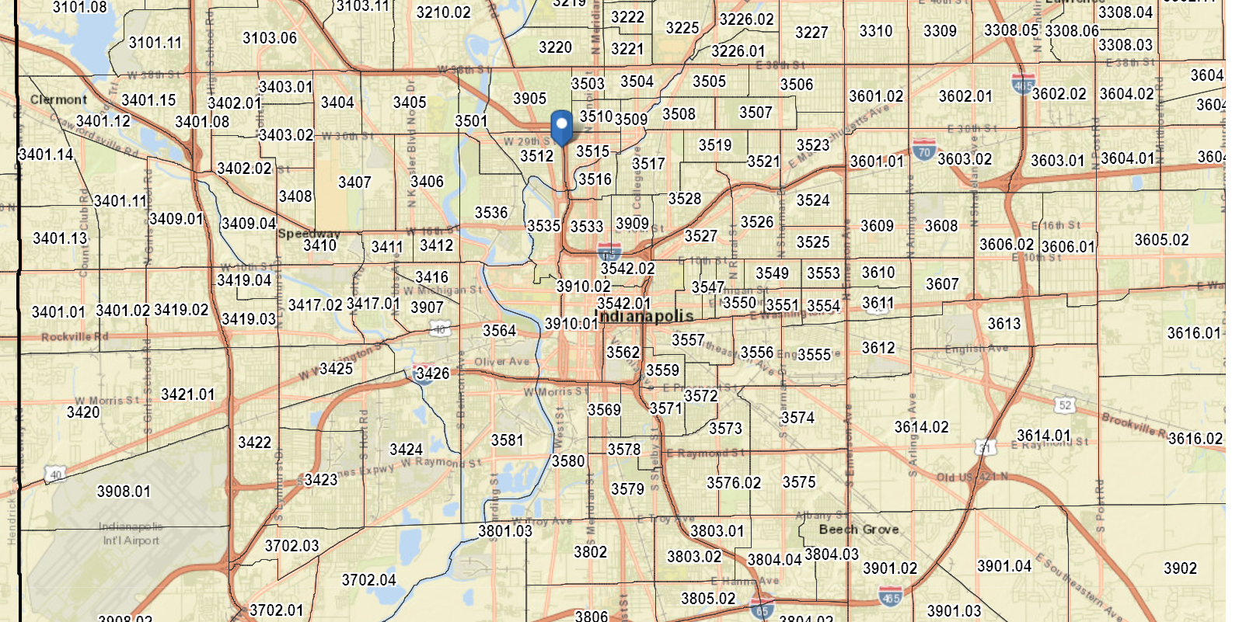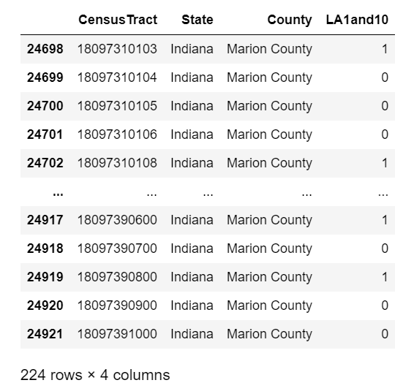

**Fig. 1.** Left isa map of Marion County that shows how the county is divided into tracts. Right is a pandas dataframe that shows how Food Access data has been collected for each tract.

**5 DATA CLEANING**

We analyzed the data in the Excel sheet and discovered null values in a couple of the columns in our dataset, so we decided to clean it up so that these null values wouldn't degrade the data's quality or cause issues during data analysis and modeling. We plotted a heatmap to visualize the missing data because there are only a few columns with null values. The heatmap below shows where the majority of the null values are concentrated. The names of the columns in our dataset are represented on the vertical axis, while the number of rows or observations is represented on the horizontal axis. The missing data is represented by the white hue. The heatmap shows that Lahunv20 has the majority of the null values. We want to know how many null values there are and in which columns they appear.

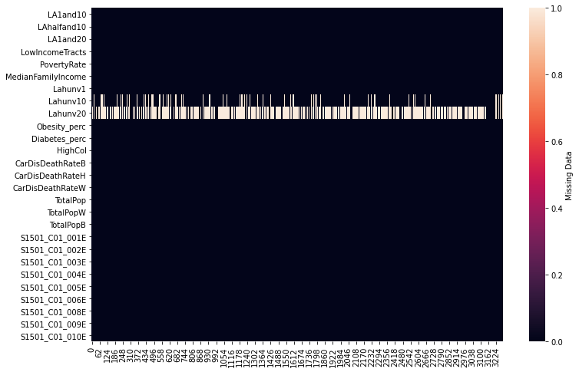

**Fig. 2.** Visualization of missing data by plotting a heatmap

We wanted to identify the number of null values and in which columns they are present.

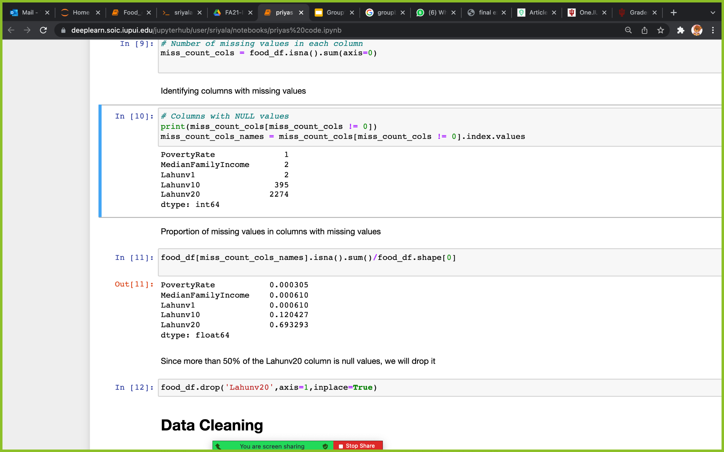

**Fig. 3.** Columns with missing values

There are a total of five columns containing null values, with Lahunv20 accounting for more than half of them. As a result, the column Lahunv20 was removed. We used the mean value to replace the null values in the other columns. For example, in the PovertyRate column (which belongs to the state SD), one null value was replaced with the mean of the PovertyRate values from all the counties in the state (SD). Similarly, we substituted null values with the mean values of that column (Lahunv1, Lahunv10, MedianFamilyIncome) in the state in which the county is based.

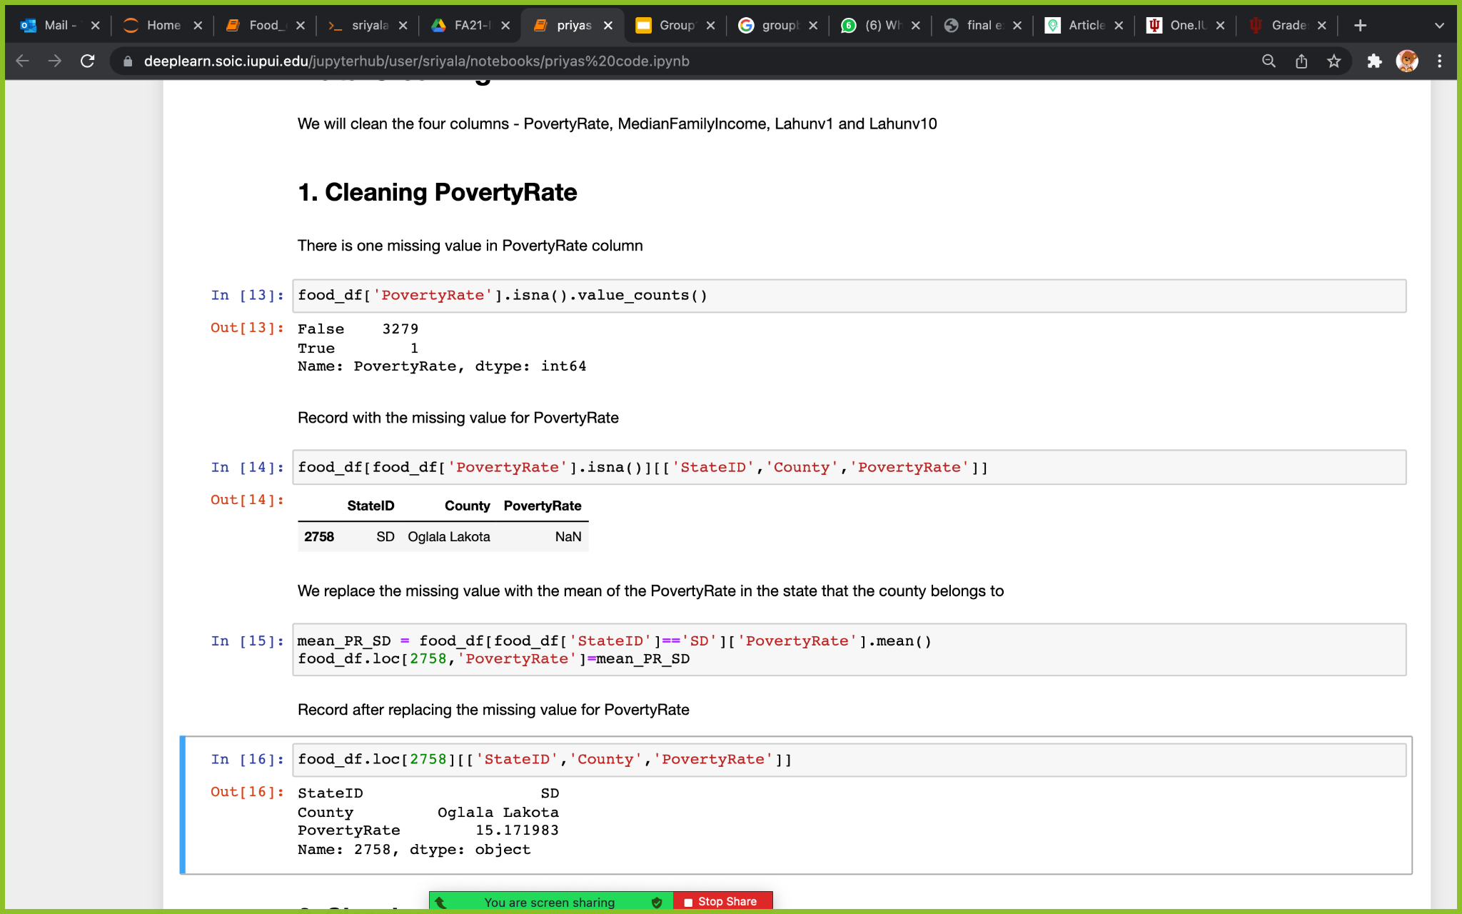

**Fig.4.** Checking and replacing missing values with mean of the column (PovertyRate) values from all the counties present in the state.

After replacing the null values, we checked if there are any further null values.

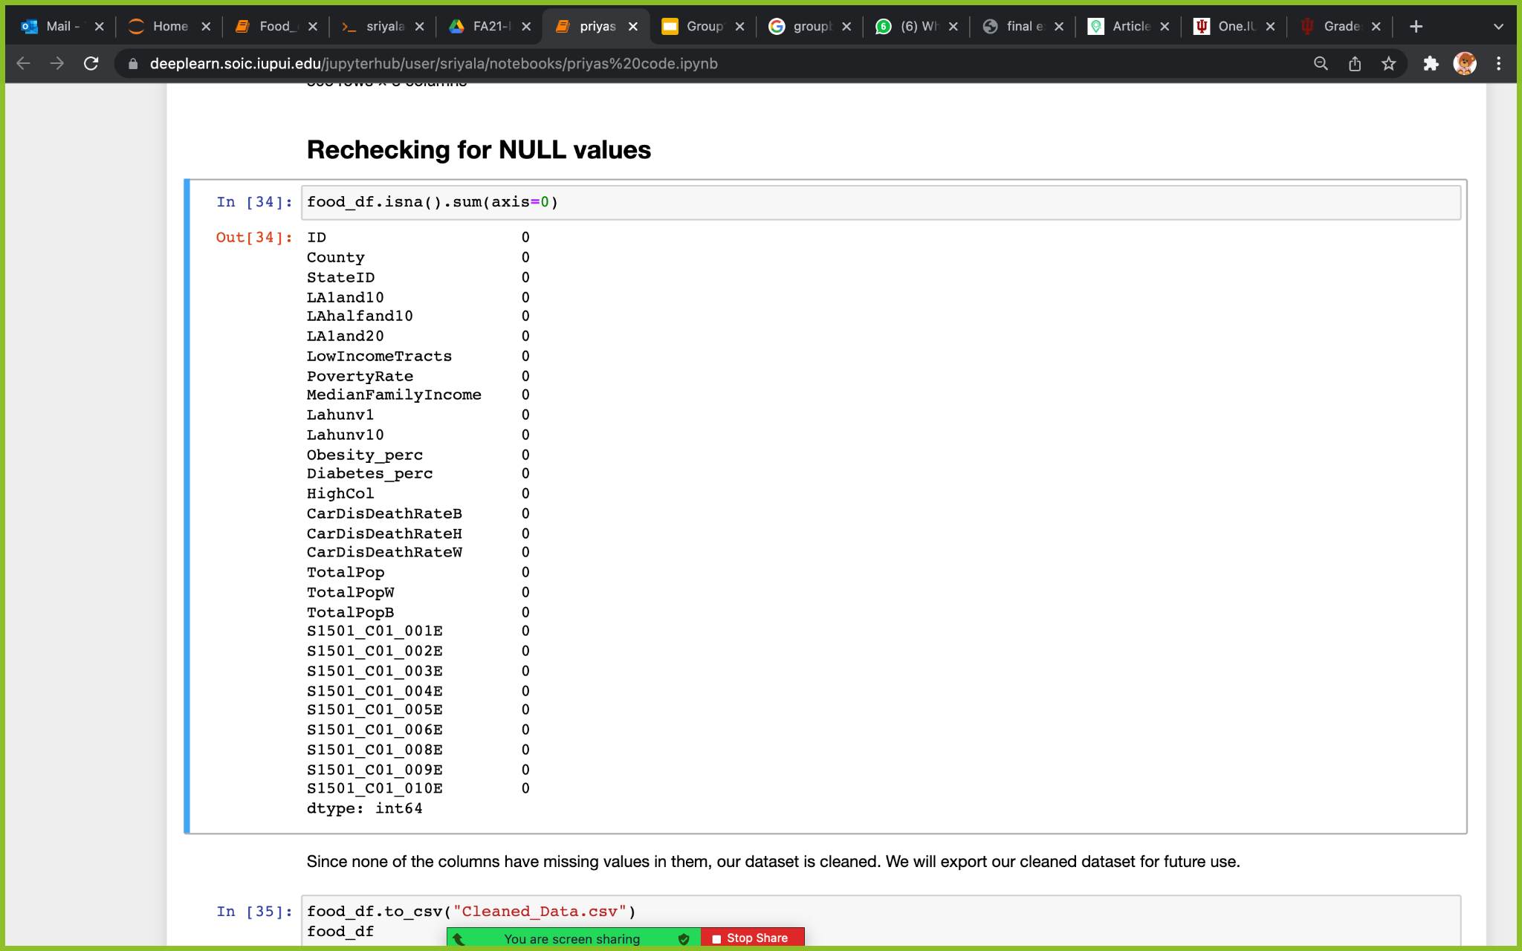

**Fig.5.** Rechecking NULL values - cleaned data without null values

After we cleaned the food_df data set, we saved it in CSV format as Cleaned_Data.csv and had the file saved.

**6 DATA VISUALIZATION AND ANALYSIS**

Target Variable/Dependent Variable: We took LA1and10 as our target variable variable because among the 3 possible target variables (LA1and10 - moderate, LAhalfand10-extreme, LA1and20-relaxed) it is the one with moderate tolerance for low food access

**6.1 VISUALIZATION**

We used python to visualize and analyze the data. Below are the steps we followed :

We visualized our data using Barcharts, Box Plots, Histograms, Choropleth maps, Correlation heatmap and Scatter Plots.

**BARCHART**

The Barchart below tells how many counties are present in each state.

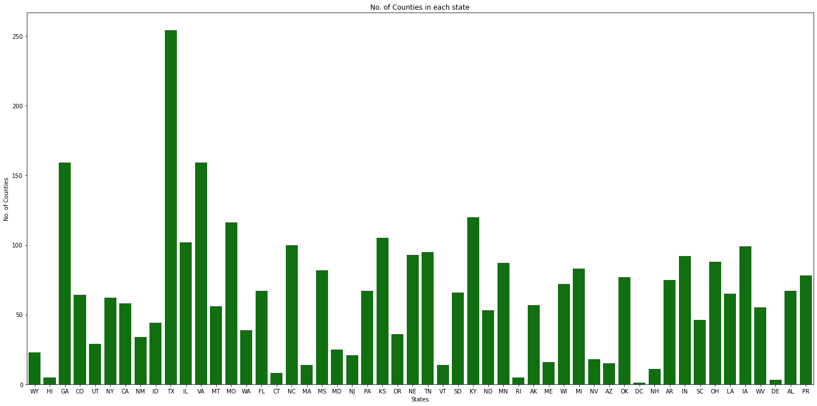

**Fig.6.** Histogram for number of counties in each state.

**BOXPLOT**

Through Box plots we want to see the range of food desserts present in each state.

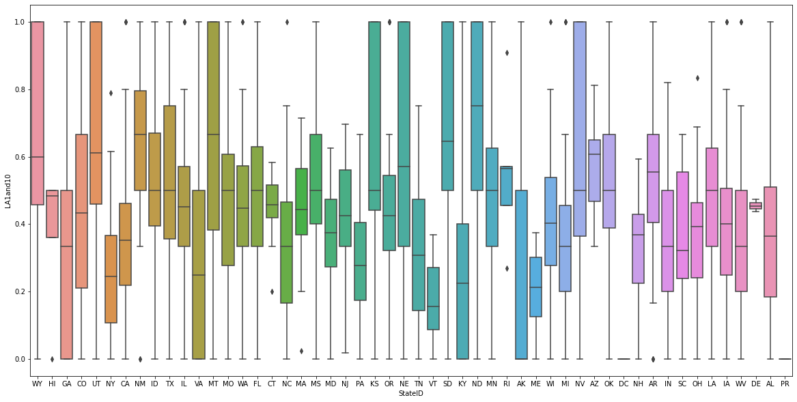

**Fig.7.** Visualization of food deserts in each state using boxplot.

**HISTOGRAM**

Through Histogram, we want to see the numerical distribution of our target variable- LA1and 10

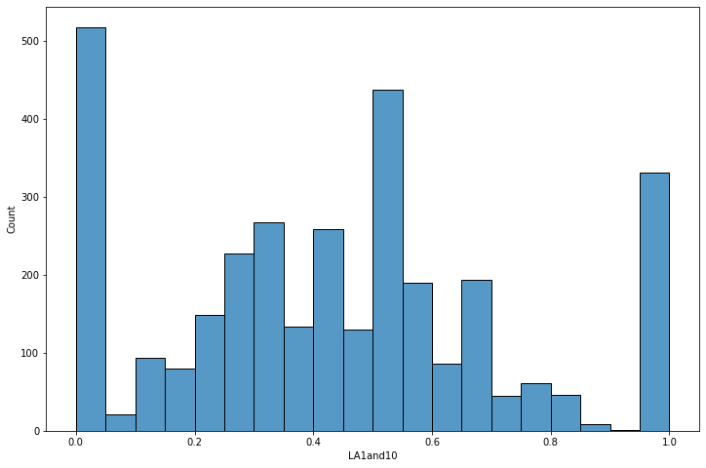

**Fig.8.** Histogram for numerical distribution for LA1and 10 (target variable).

**CHOROPLETH MAPS**

We want to see the top five states geographically that significantly has unhealthy conditions(Obesity, Cardiovascular diseases, Diabetes, Cholesterol), poor socioeconomic factors(PovertRate, MedianFamilyIncome, LowFamilyIncome)

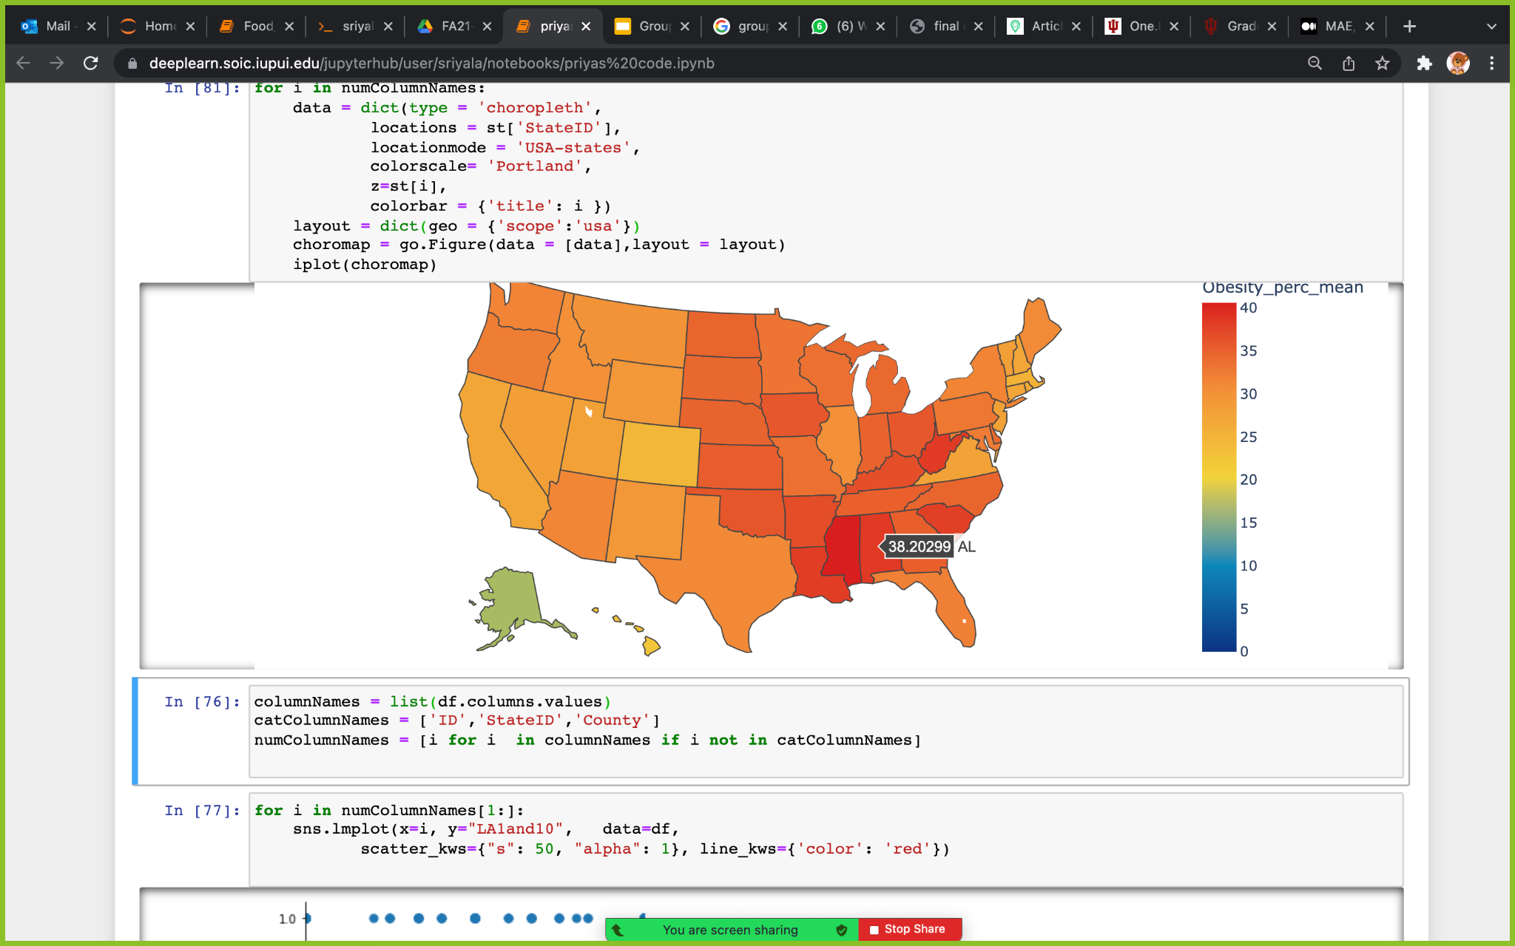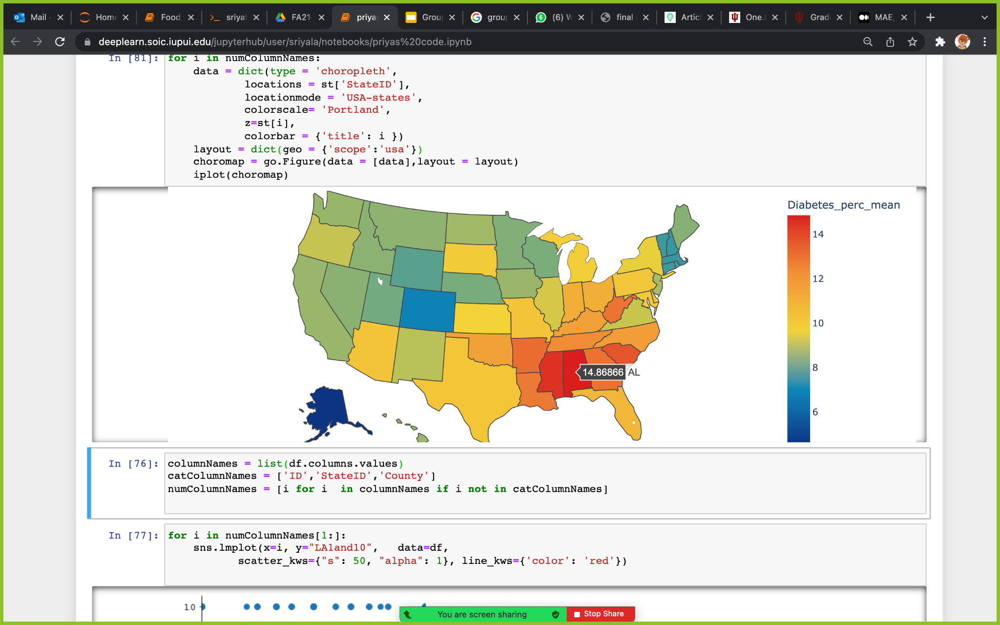

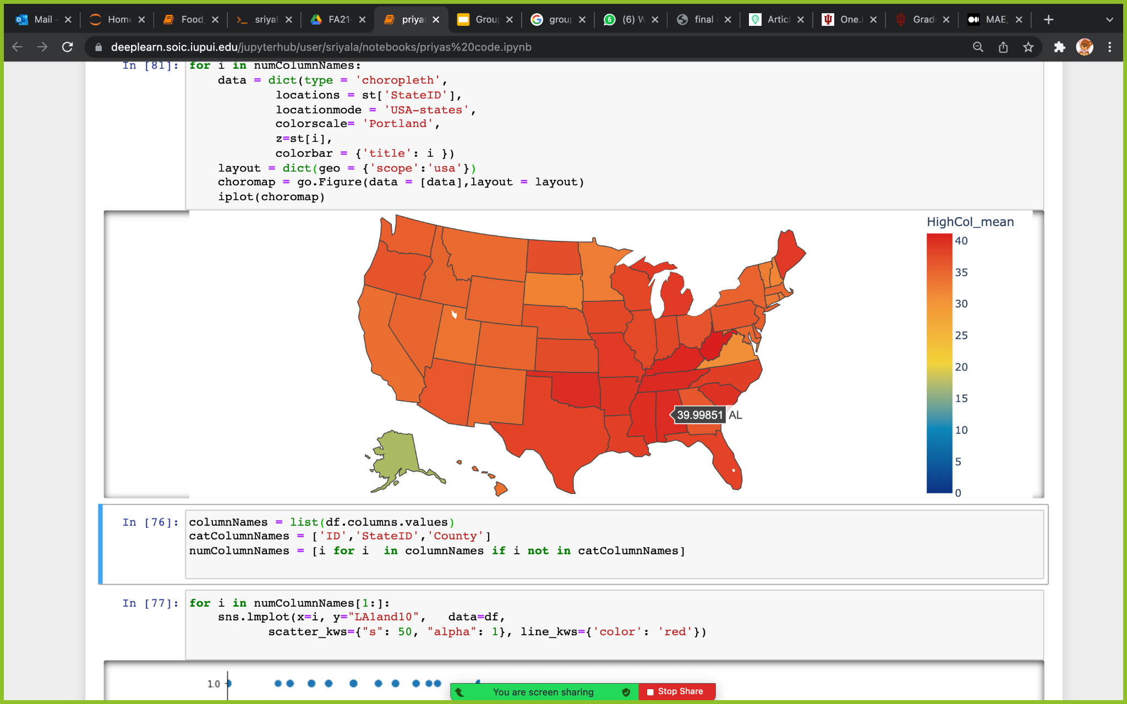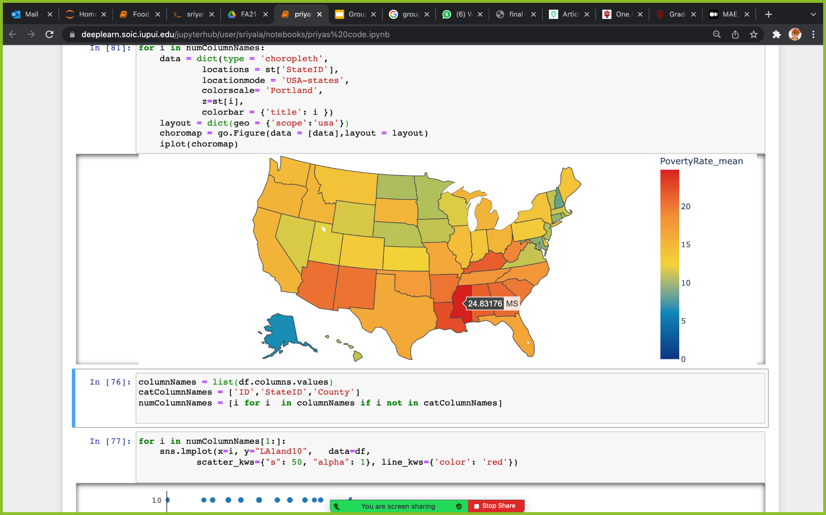

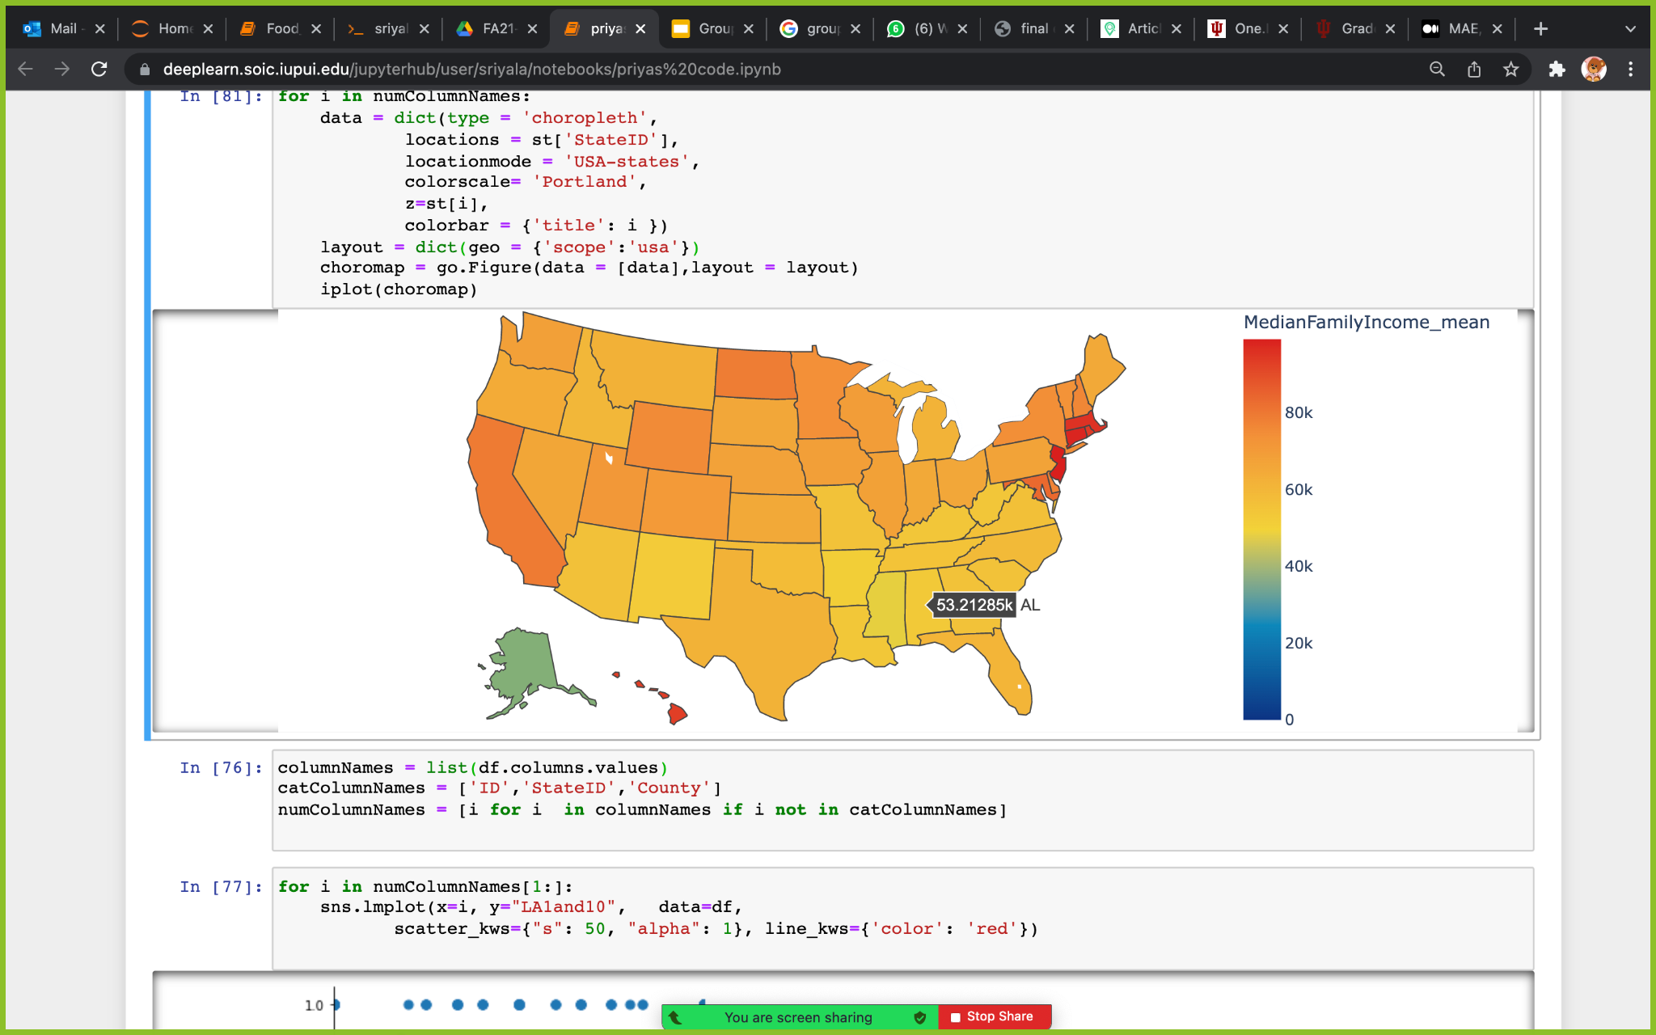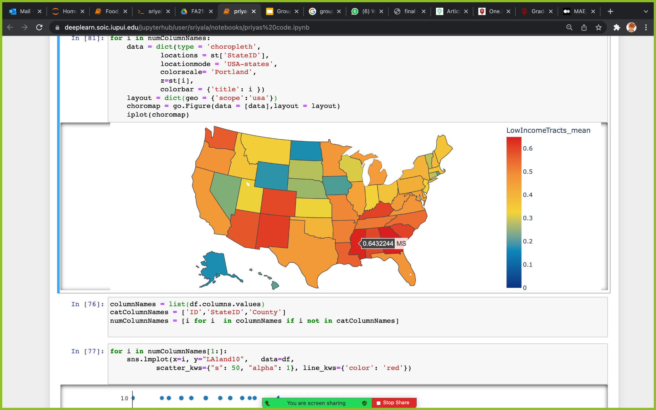

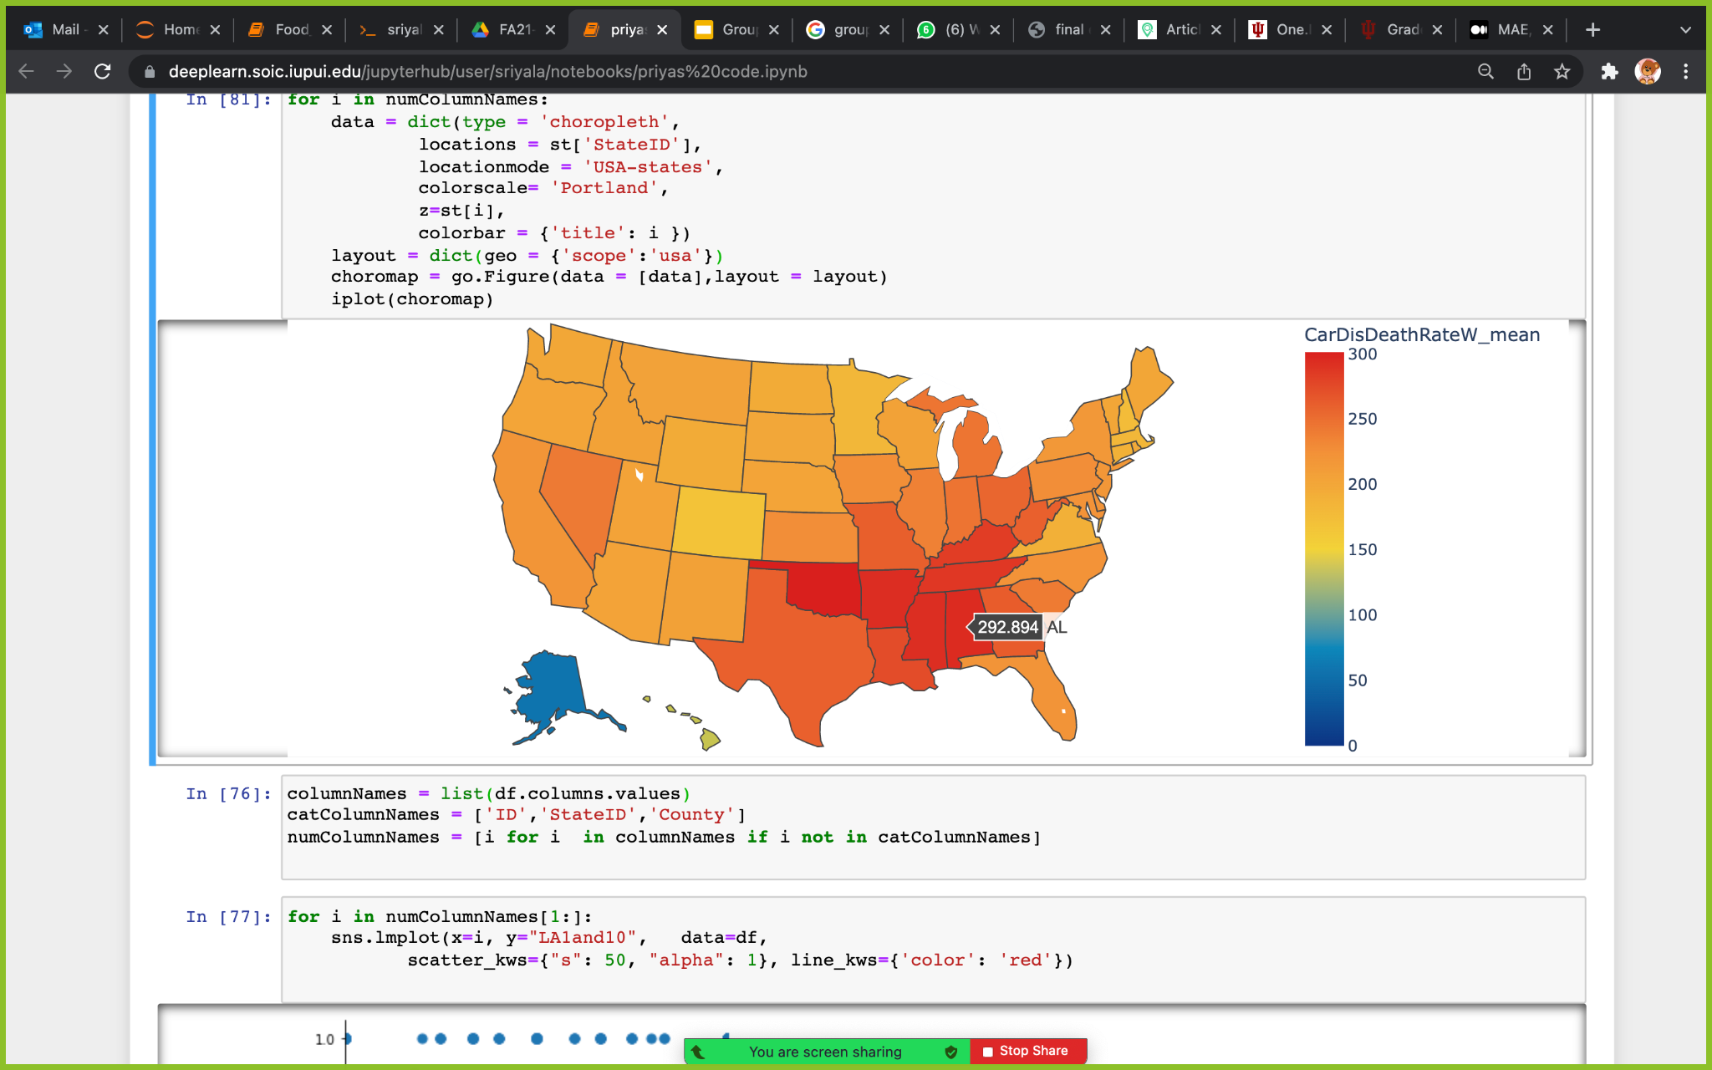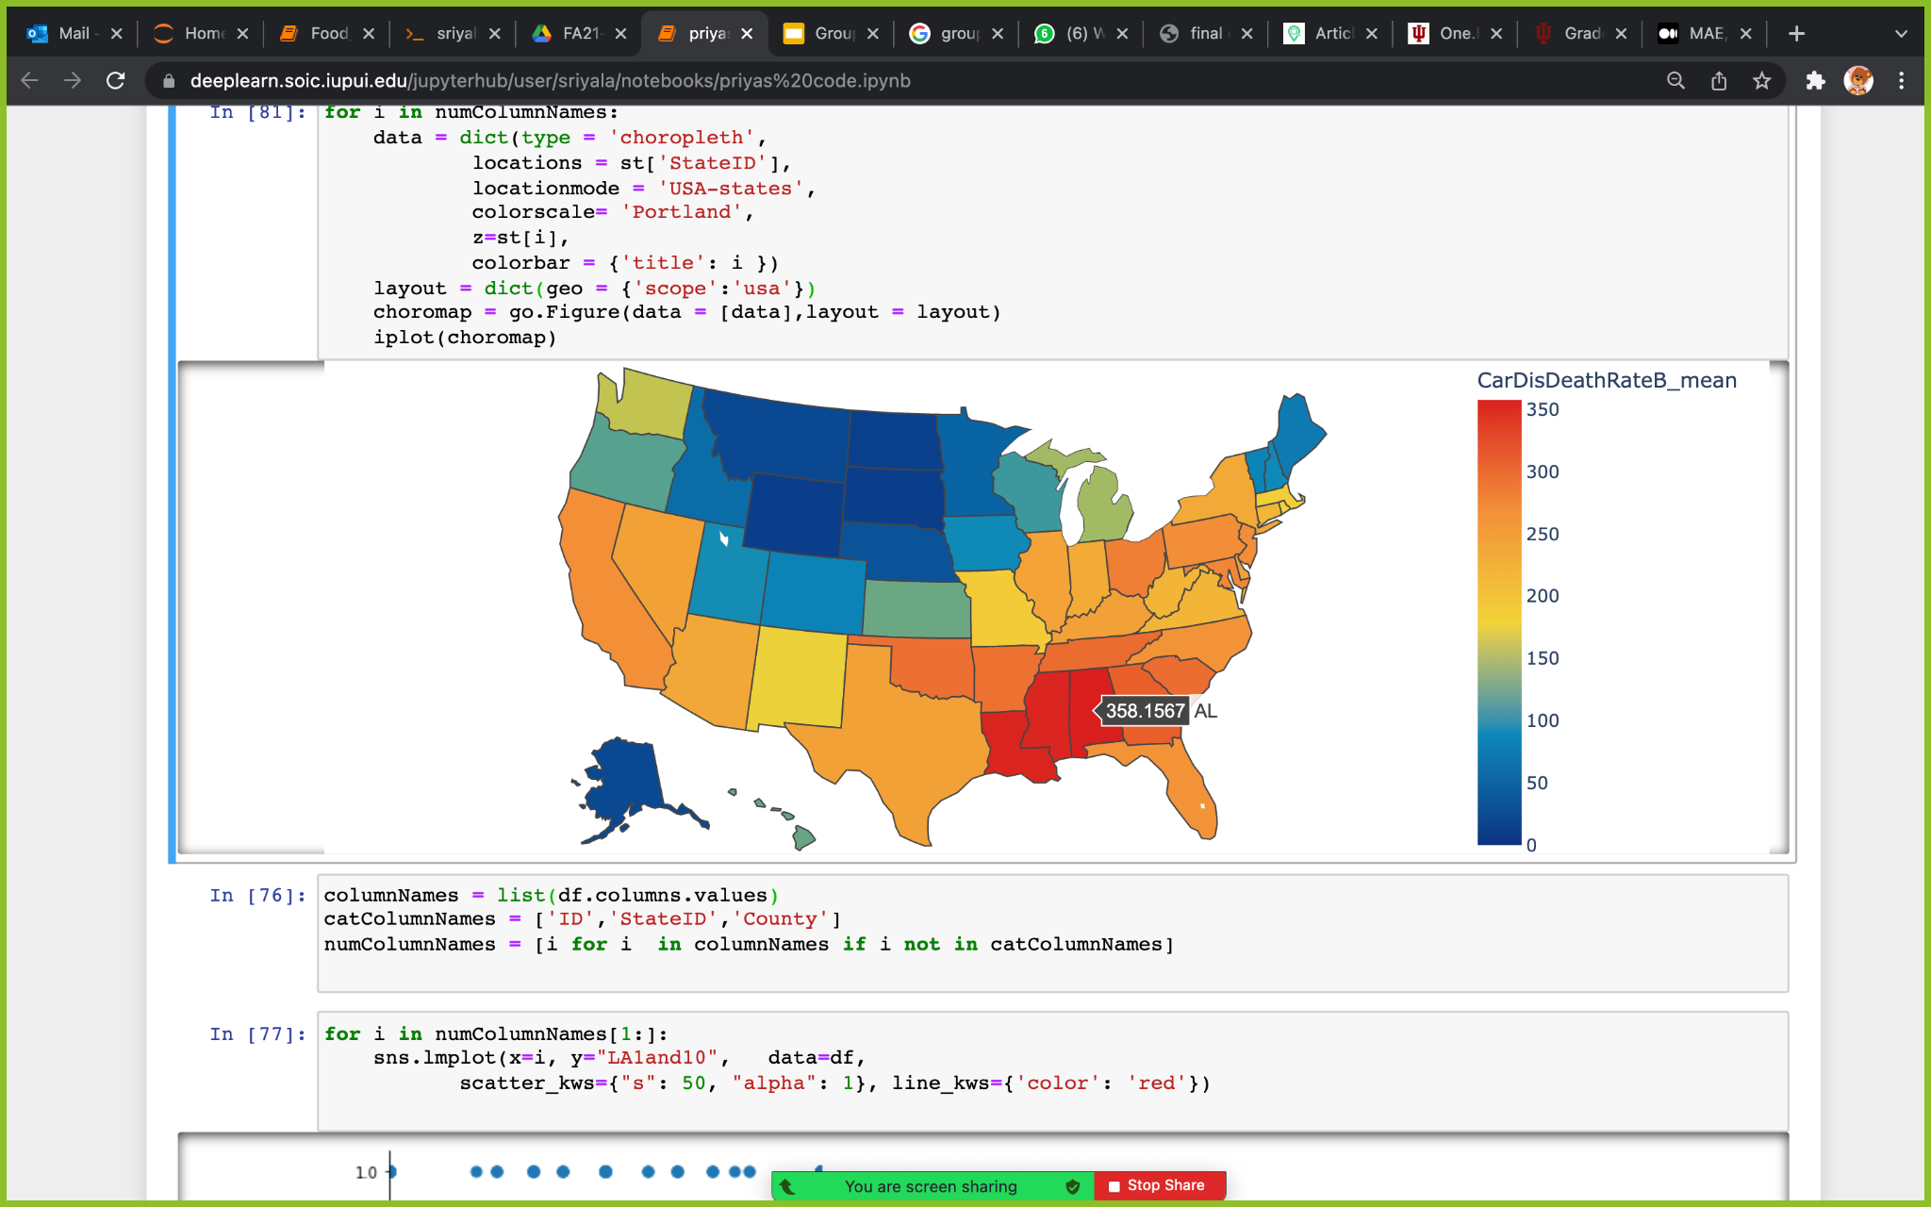

**Fig.9.** Geographical distribution of unhealthy conditions(Obesity, Cardiovascular diseases, Diabetes, Cholesterol), poor socioeconomic factors(PovertRate, MedianFamilyIncome, LowFamilyIncome) **-** Choropleth maps.

**6.2 CORRELATION BETWEEN THE TARGET VARIABLE AND OTHER ATTRIBUTES**

To find the correlation of our target variable (LA1and10) with other variables, we did a correlation test and plotted a heatmap.

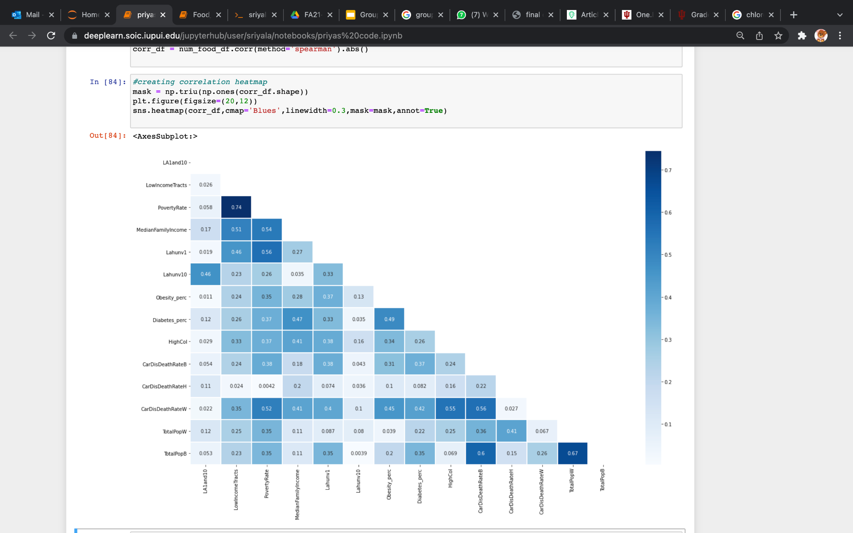

**Fig.10.** Code to display heatmap for correlation.

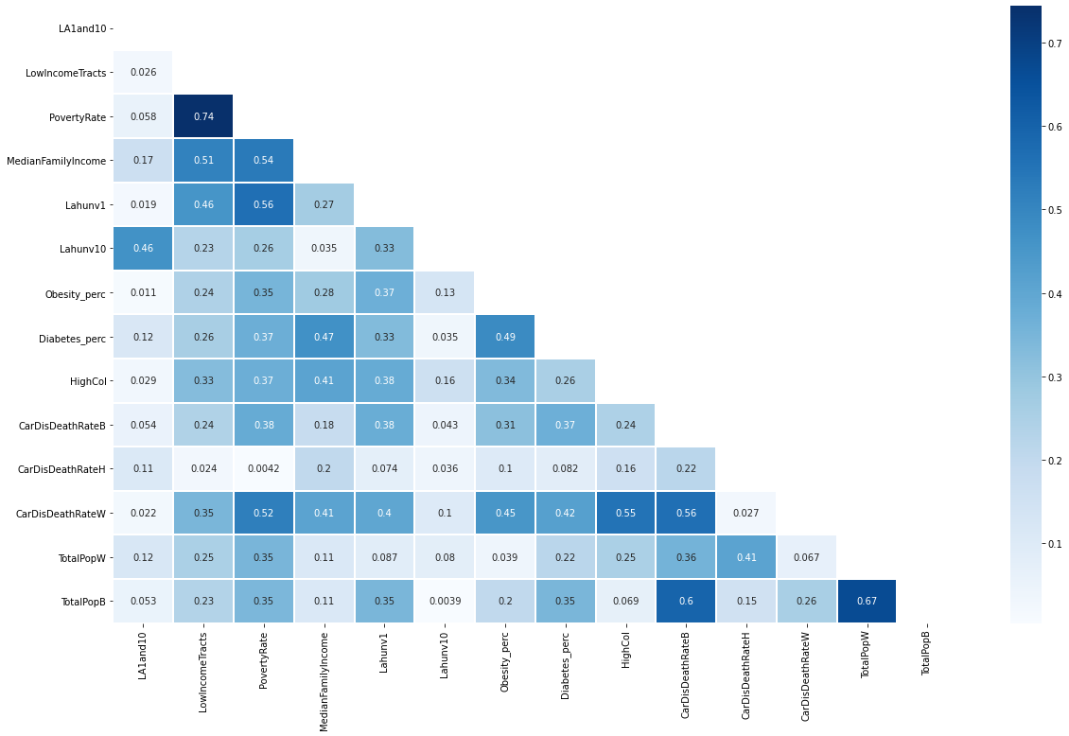

**Fig.11.**  heatmap showing correlation between variables.

After interpreting the correlation heatmap, we found that LA1and10 (in all the states and counties) doesn't have any good correlation with the other attributes.

**7 EXPLORATORY DATA ANALYSIS**

We want to check which top five states are unhealthy, has poor socioeconomic factors

**TOP FIVE UNHEALTHY STATES**

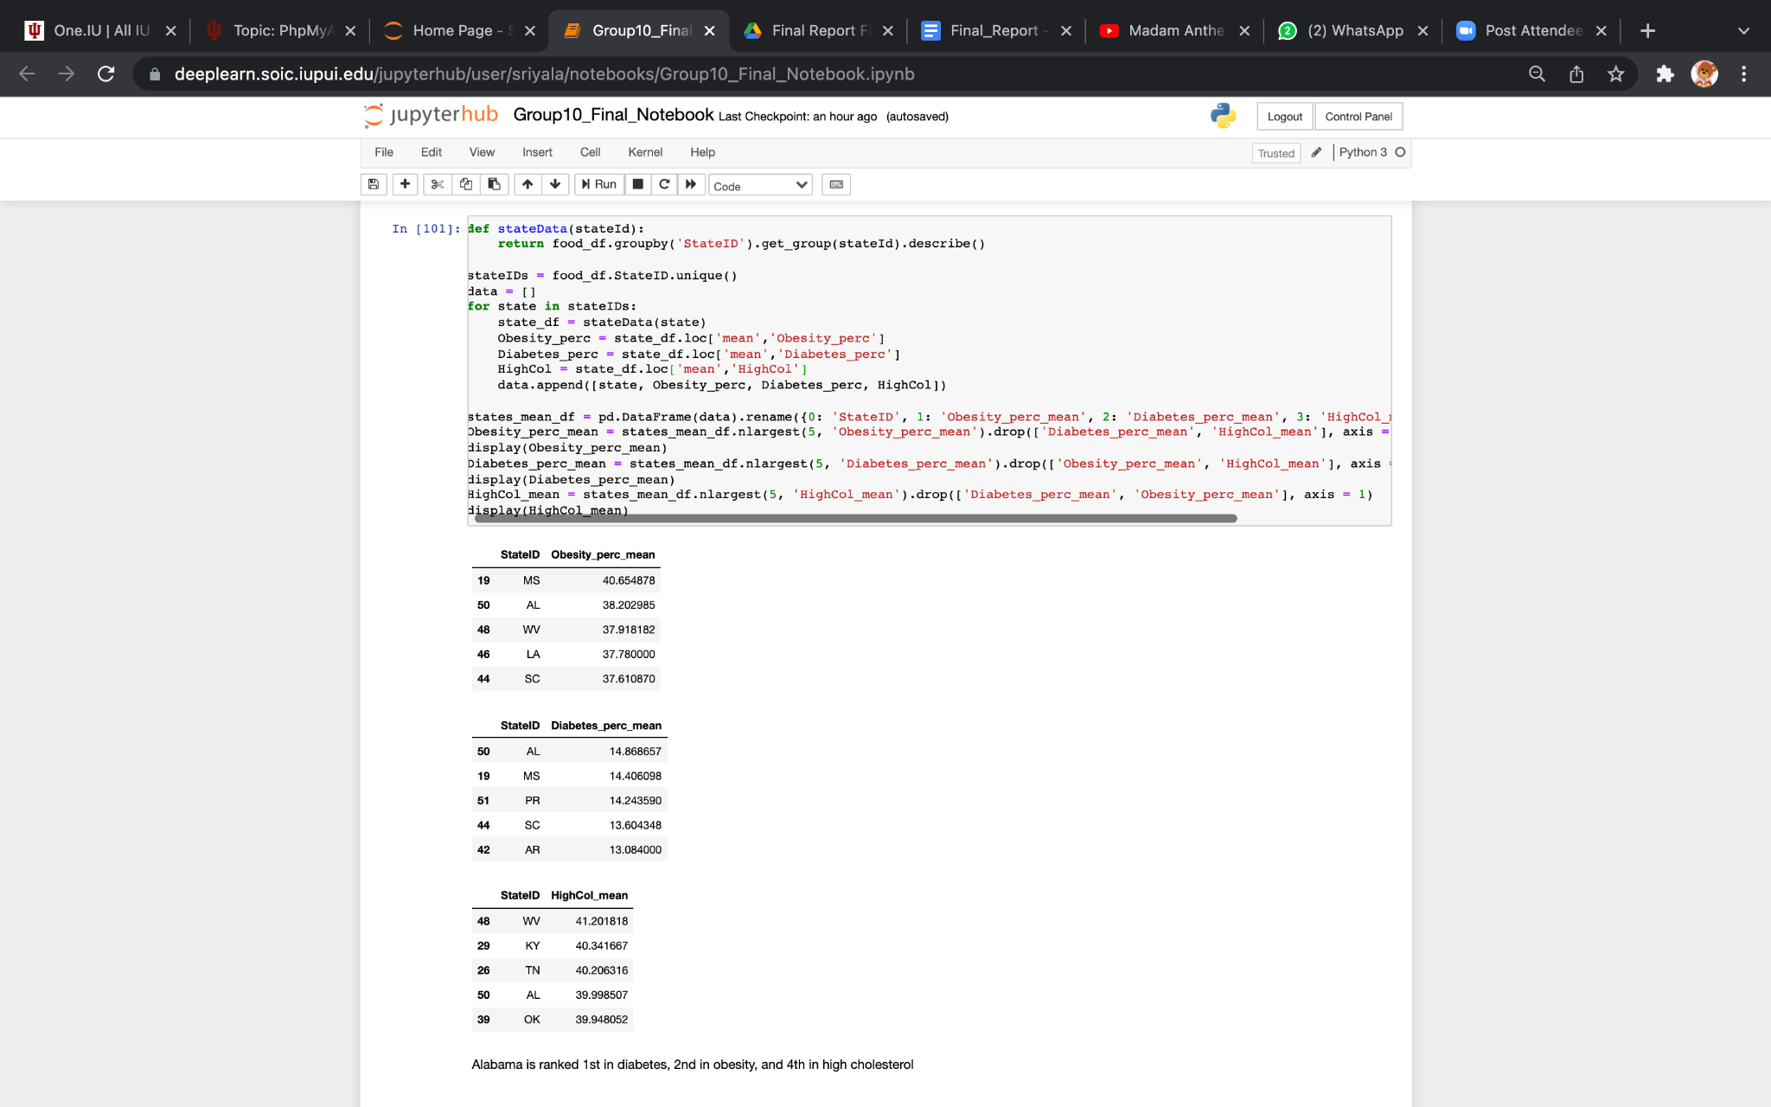

**Fig.12.** Code for displaying top five states based on poor health conditions .

  

**Fig.13.** Tables showing top 5 States with high obesity, cholesterol, diabetes.

**TOP FIVE IMPOVERISHED STATE**

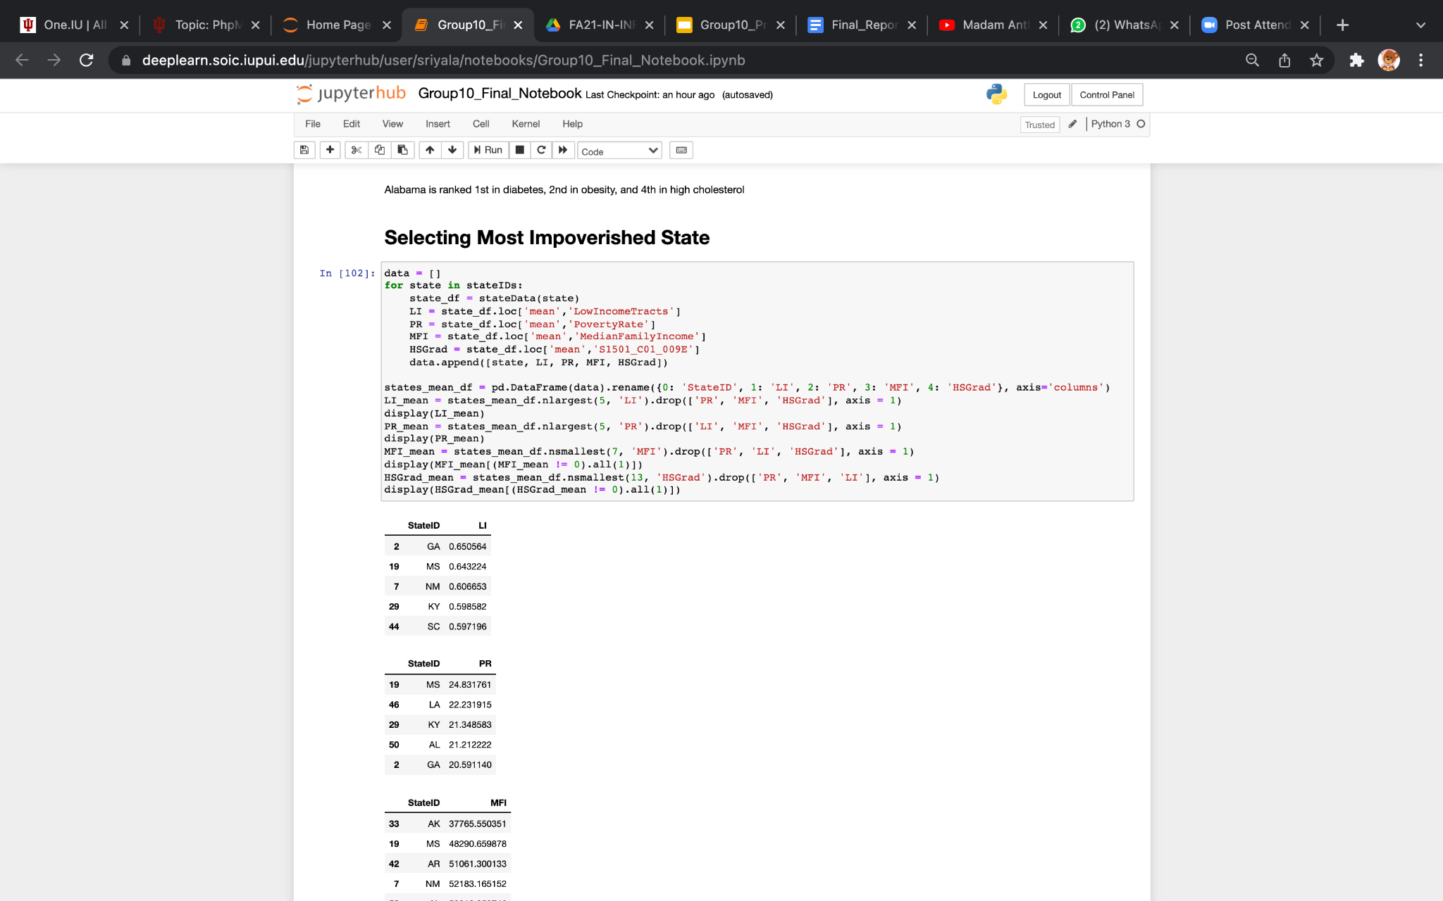

**Fig.14.** Code for displaying top five states based on socioeconomic factors .

  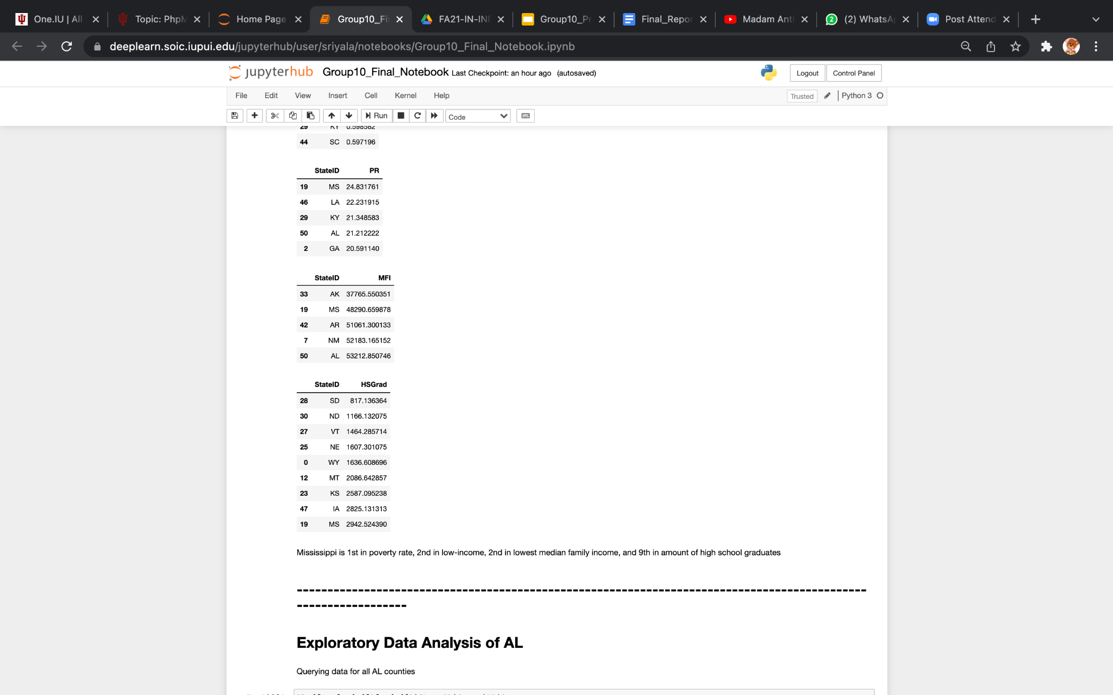 

**Fig.13.** Tables showing top 5 States with poor socioeconomic factors.

We picked Alabama, Mississippi for further analysis as they are found to be in top 5 states having poor health conditions and low socioeconomic status .

*Health data ranking*

Alabama:

* #1 in diagnosed diabetes
* #2 in obesity
* #4 in high cholesterol

*Socioeconomic data ranking*

Mississippi

* #1 in poverty rate
* #2 in low-income
* #2 in median family income
* #9 in population only having high-school graduate

**7.1 ALABAMA**

**ALABAMA CORRELATION HEAT MAP**

We plotted a correlation heatmap to see the correlation of the target variable(LA1and10) and other variables. Top correlation of LA1AND10 was found with only the population of African-American, Poverty Rate and Obesity.

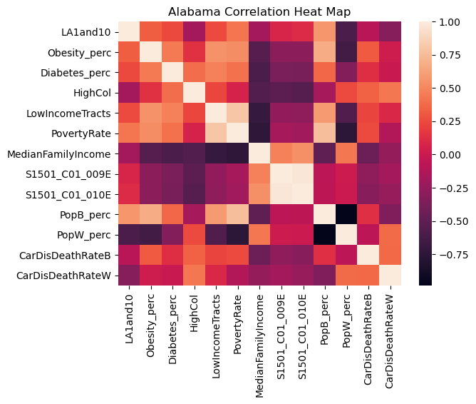

**Fig.14.** Alabama correlation heat map

**NORMALITY TEST**

We want to analyze if our data assigned to Alabama state is normally or not normally distributed . We did Shapiro-Wilk test on the dependent and independent variables, where the cut off p value is 0.05. LA1and10, LowIncomeTracts, CarDisDeathRateB columns have p value >0.05 indicating that these columns are normally distributed while the other columns Obesity_perc Diabetes_perc, HighCol, PovertyRate, MedianFamilyIncome, S1501_C01_009E, S1501_C01_010E, PopB_perc, PopW_perc, CarDisDeathRateW, Lahunv1 columns have p value<0.05 indicating that these columns are not normally distributed.

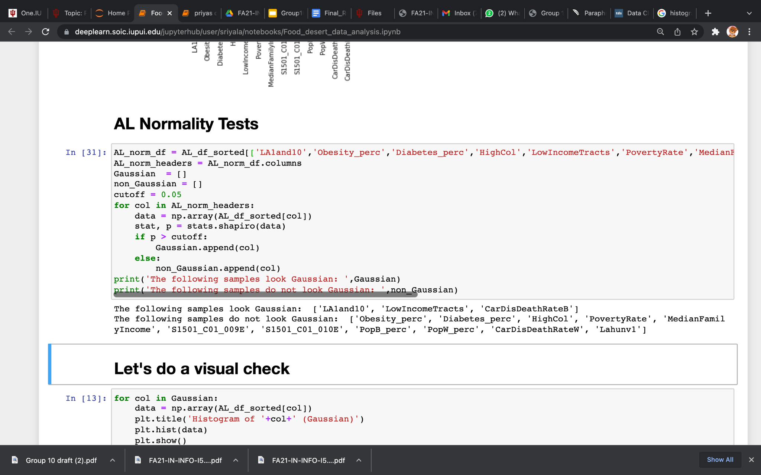

**Fig.15.** Code to determine normally and not normally distributed columns.

We want to analyze the association of food deserts with health conditions and socioeconomic factors. So, first we sorted out the top five states that are most unhealthy(highest obesity, cholesterol, diabetes and cardiovascular diseases) and poor socioeconomic factors(MedianFamilyIncome, PovertyRate, LowFamilyIncome). Also, we want to analyze if white or black population is concentrated in the top five states that are unhealthy.

**GAUSSIAN VISUAL DISTRIBUTION**

We plotted histograms for Gaussian Columns and Non-Gaussian columns

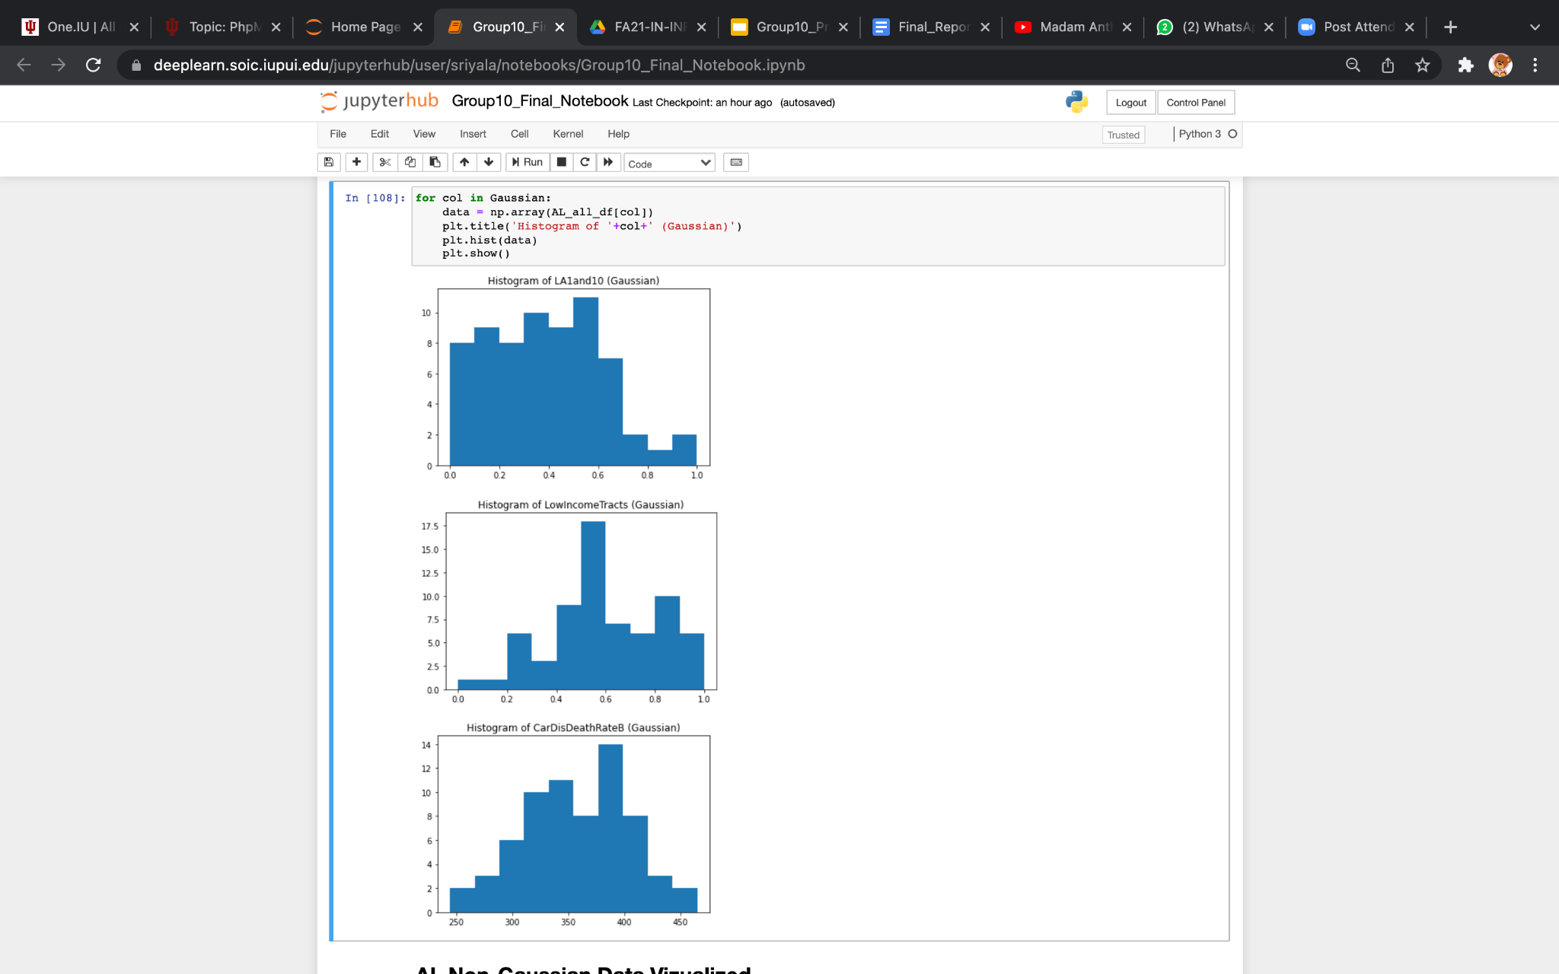

**Fig.16.** Code for histograms for Normally Distributed Data.

 

**Fig.17.** Histograms for Normally Distributed Data(Gaussian).

**NON - GAUSSIAN VISUAL DISTRIBUTION**

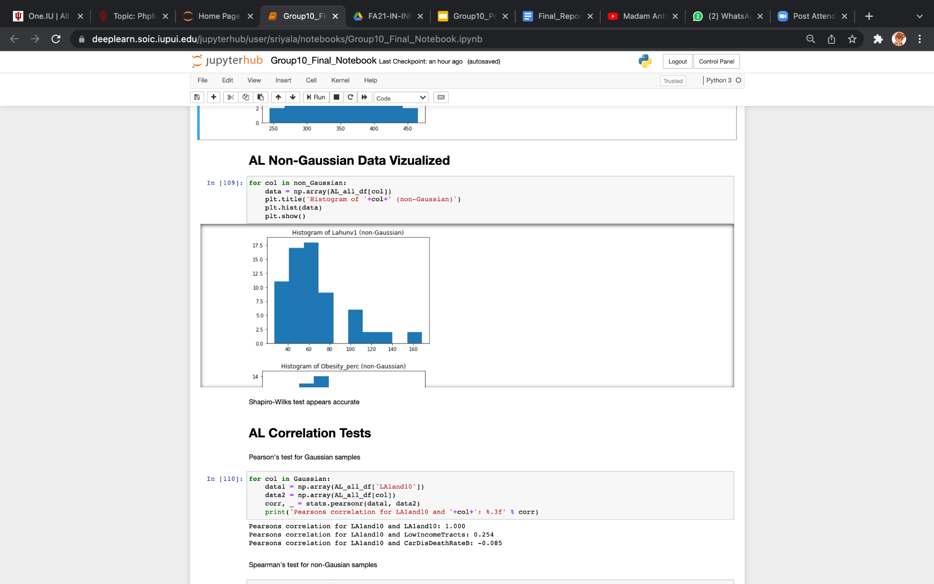 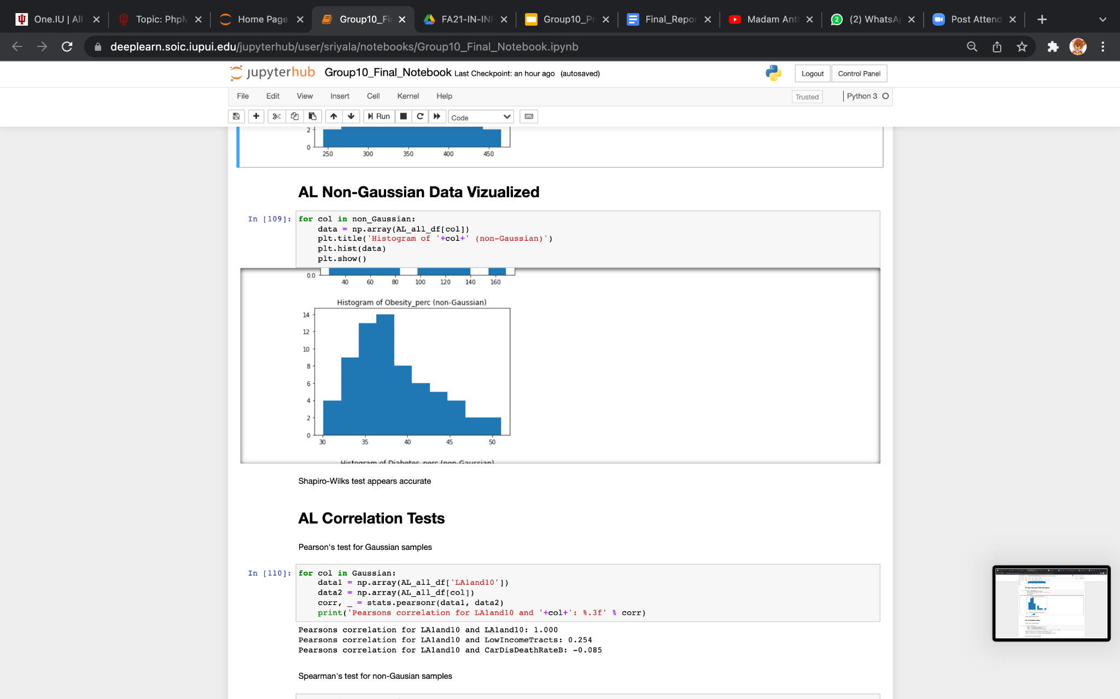 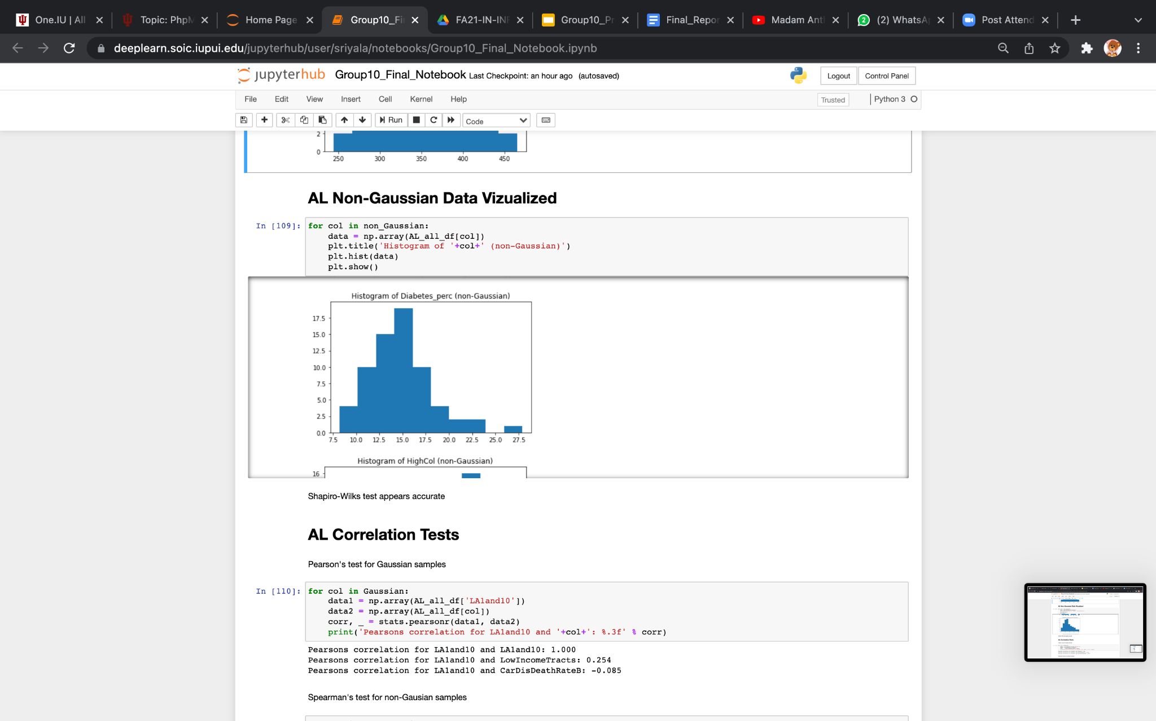

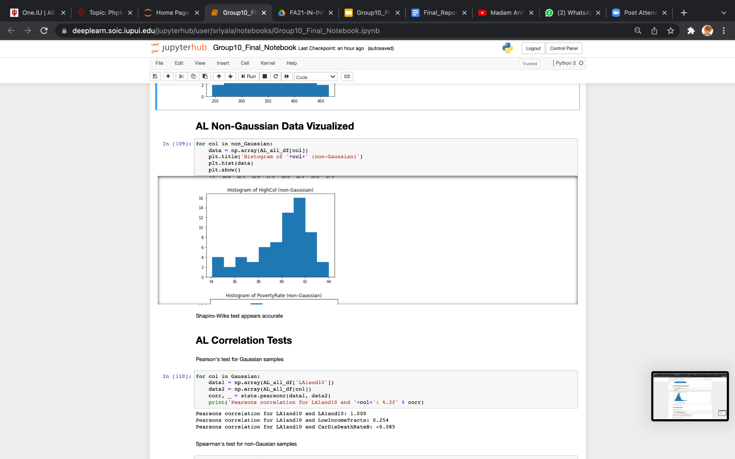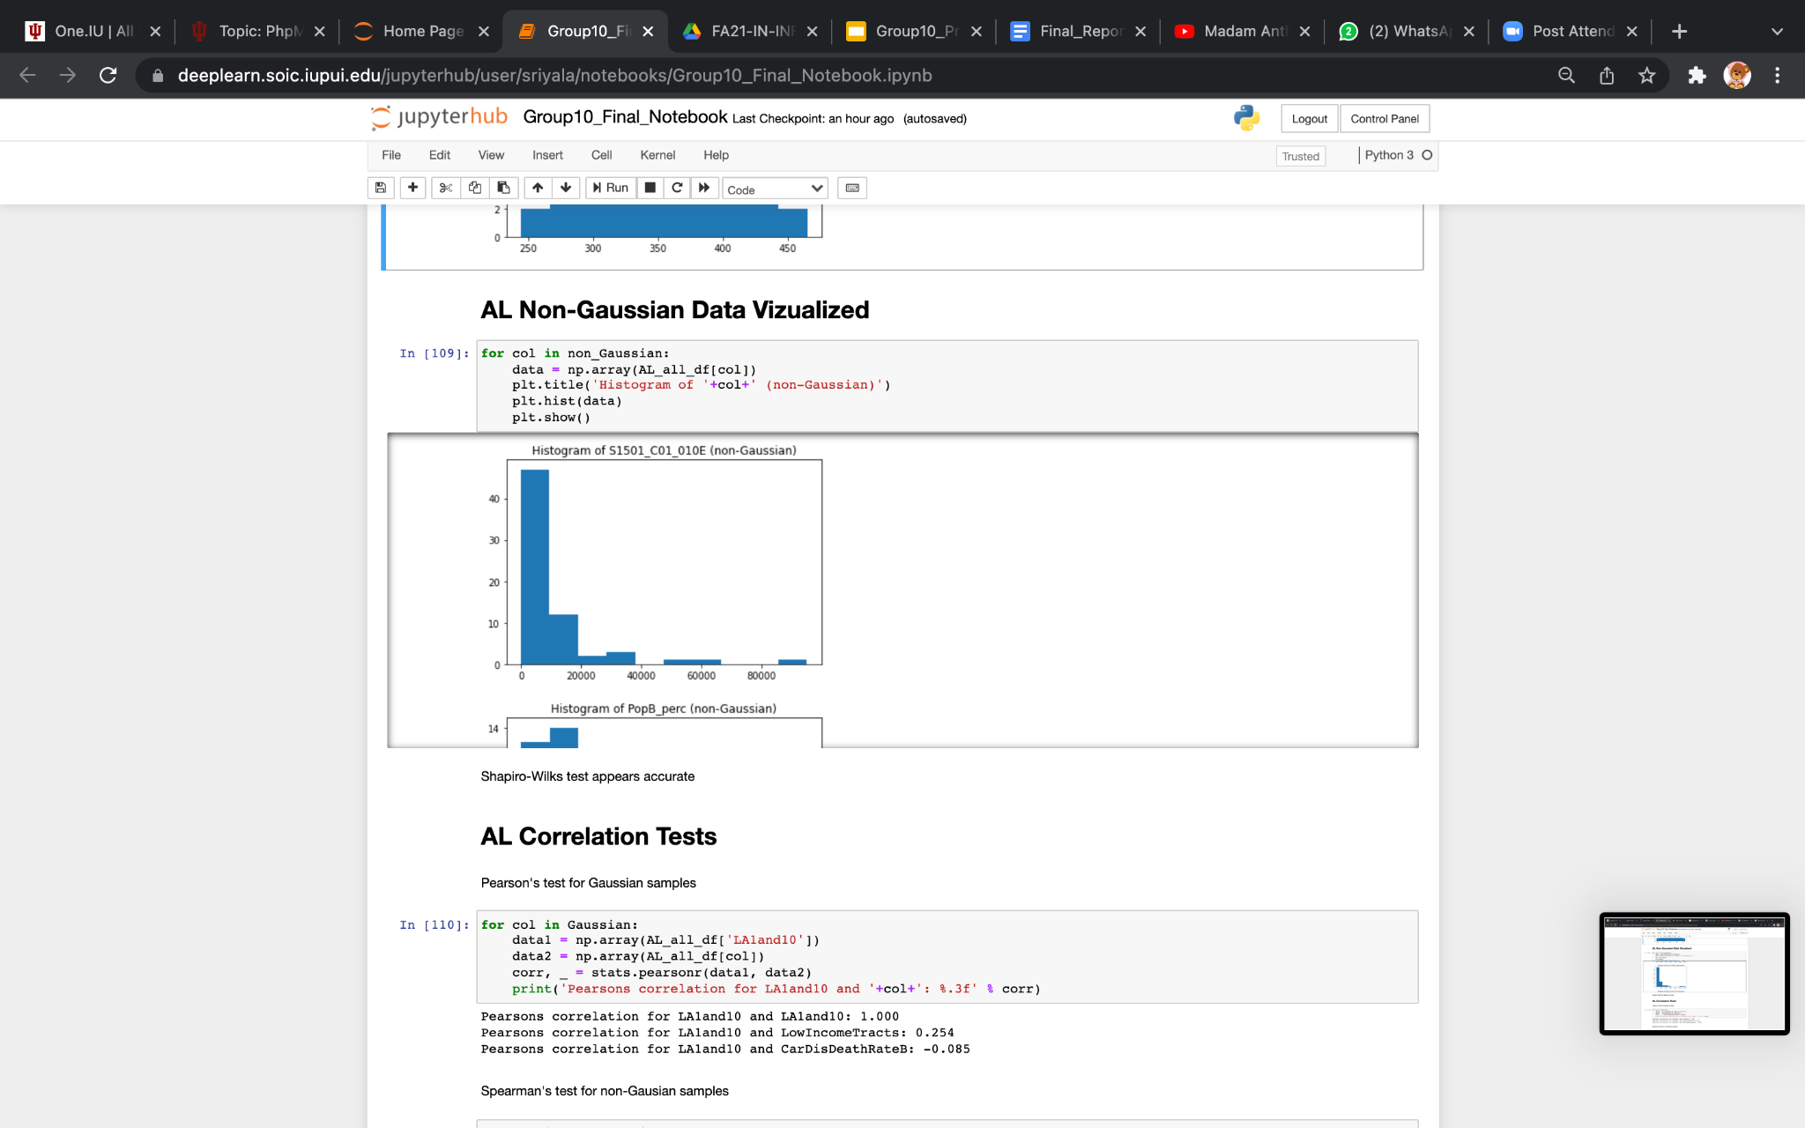 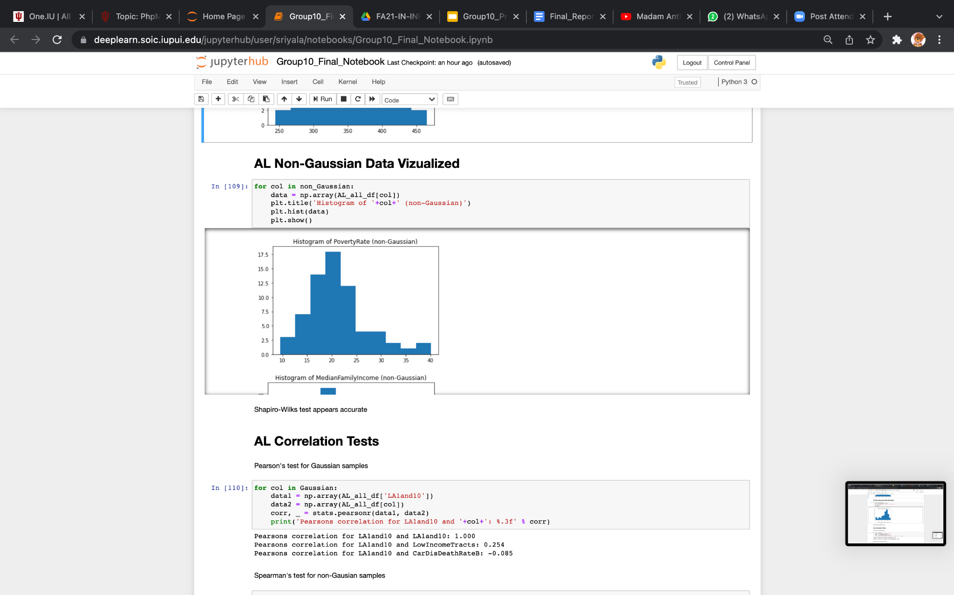

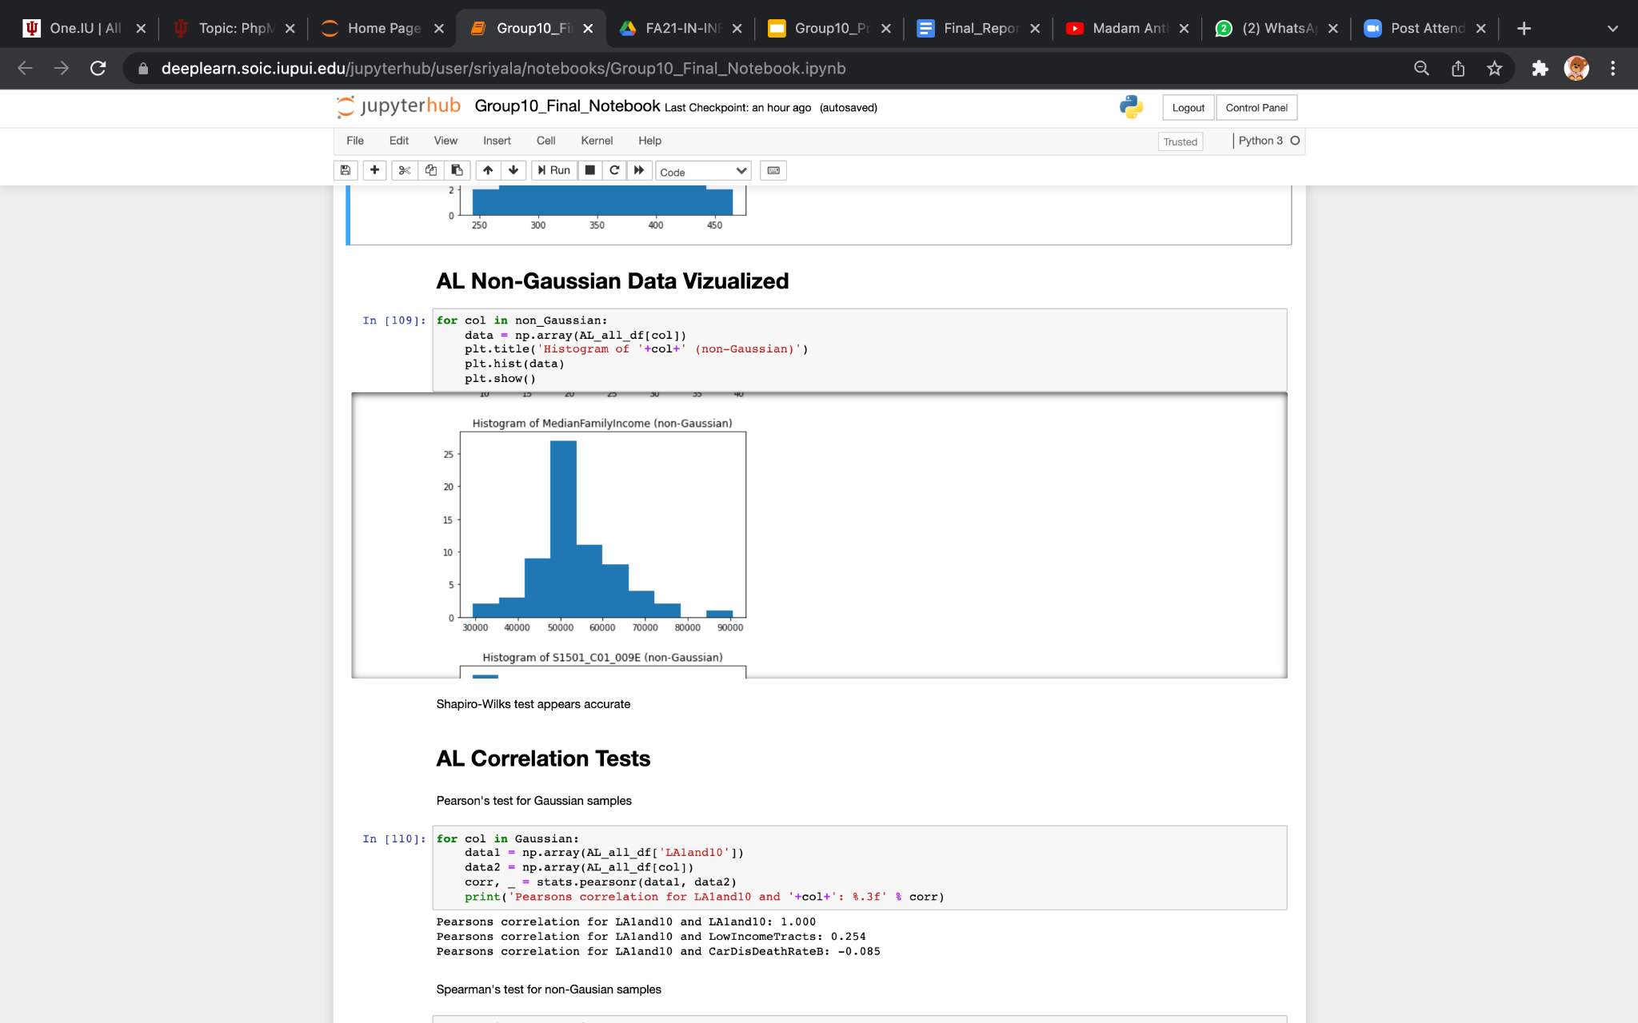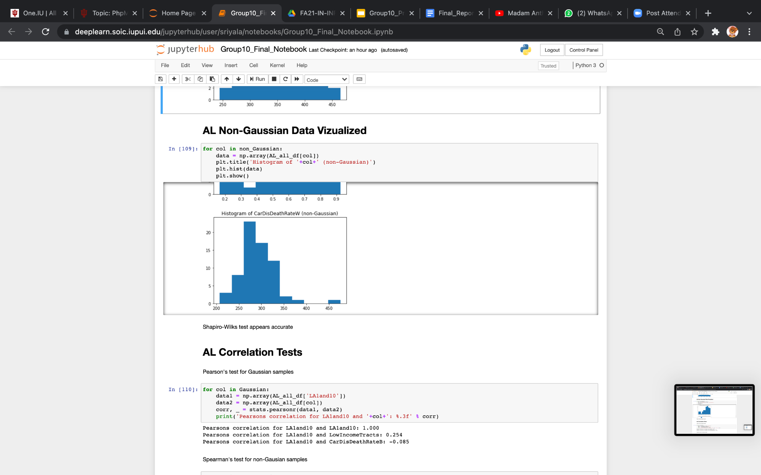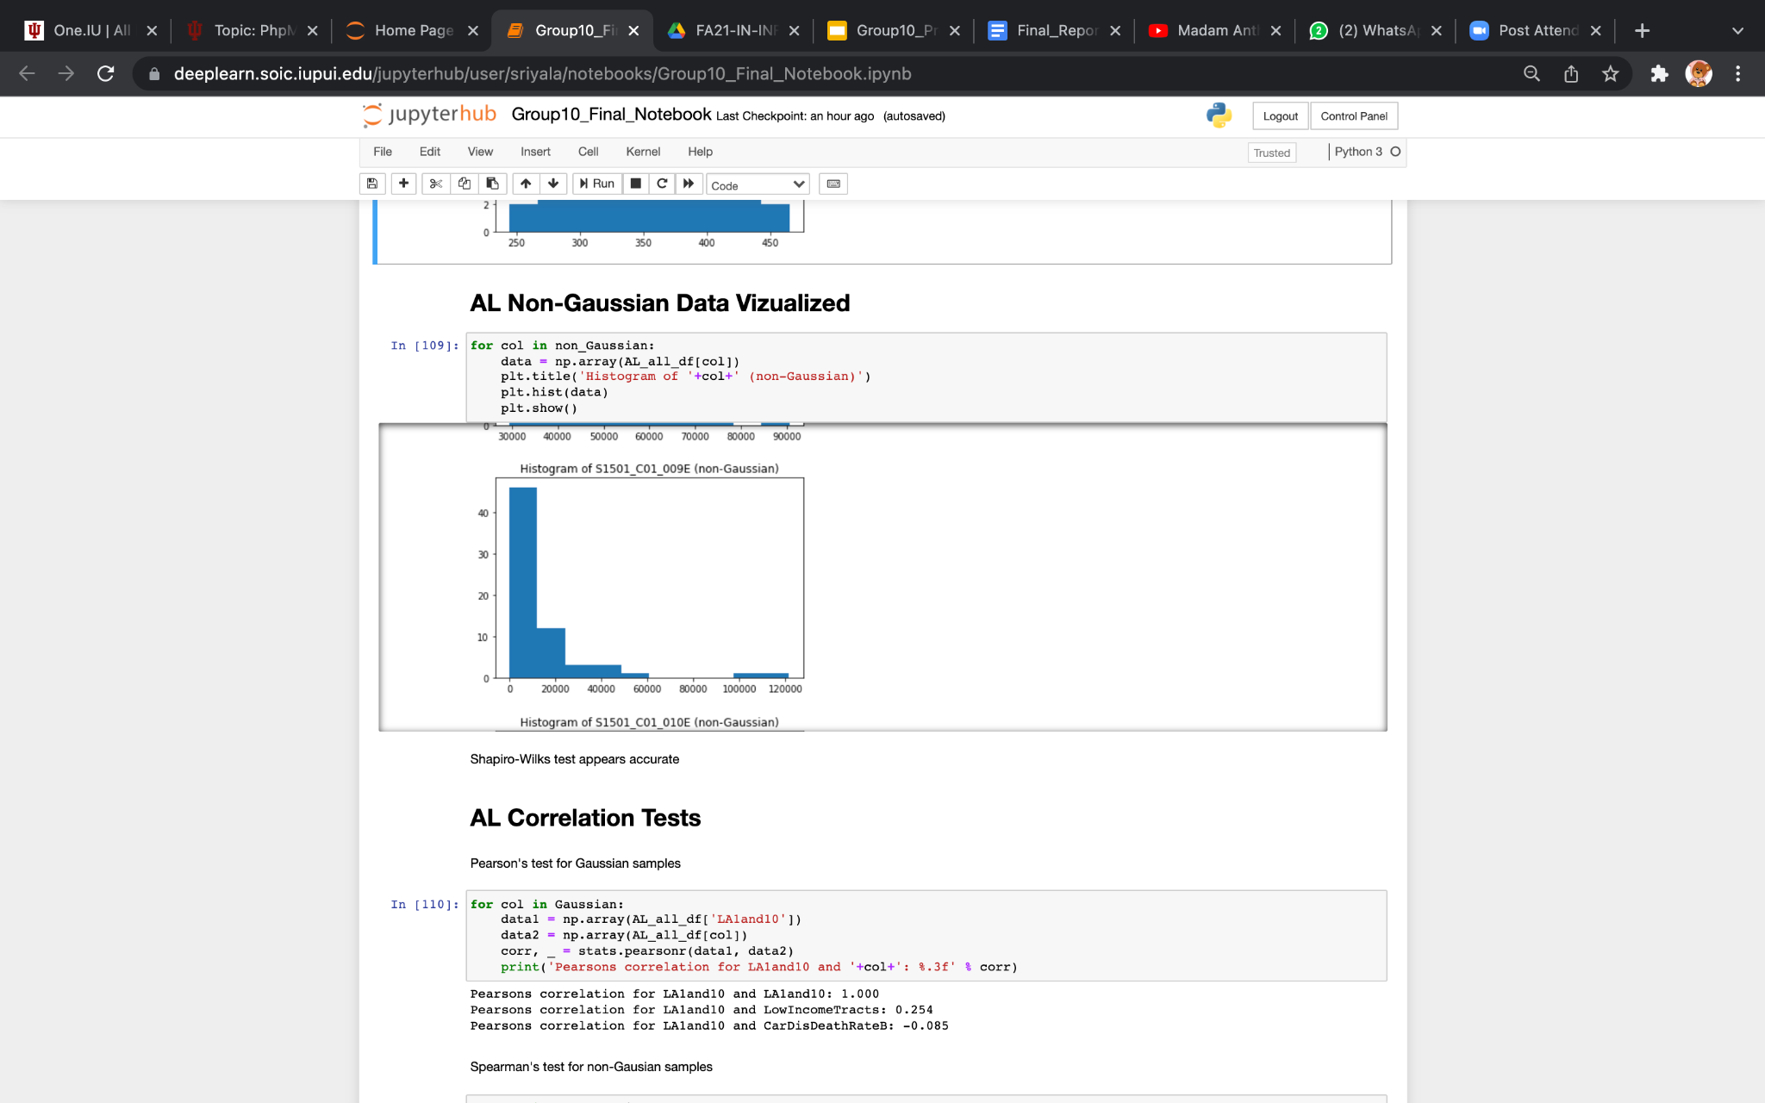

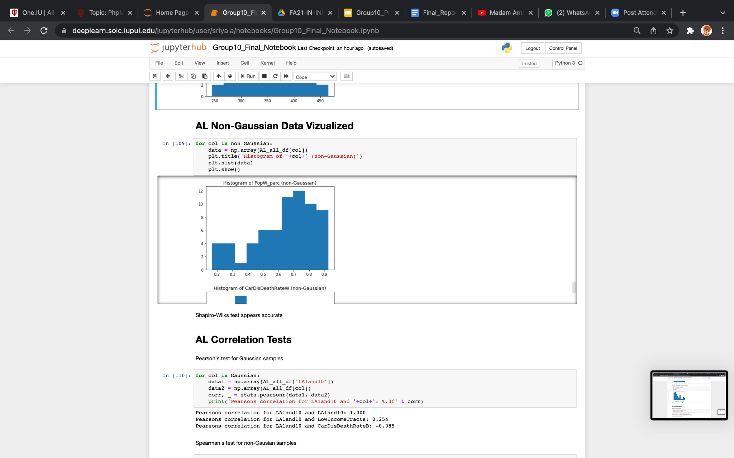

**Fig.17.** histograms for not Normally Distributed Data(Non -Gaussian).

**ALABAMA'S CORRELATION TEST**

We did Pearson's correlation test for normally distributed data(Gaussian) whereas for not normally distributed data, we did Spearman’s correlation test. For both the tests we correlated the target variable (LA1and10) with the other variables. Our test results indicate that LA1and20 has a considerable correlation with Obesity, LowIncomeTracts, PovertyRate, Diabetes and Black Population.

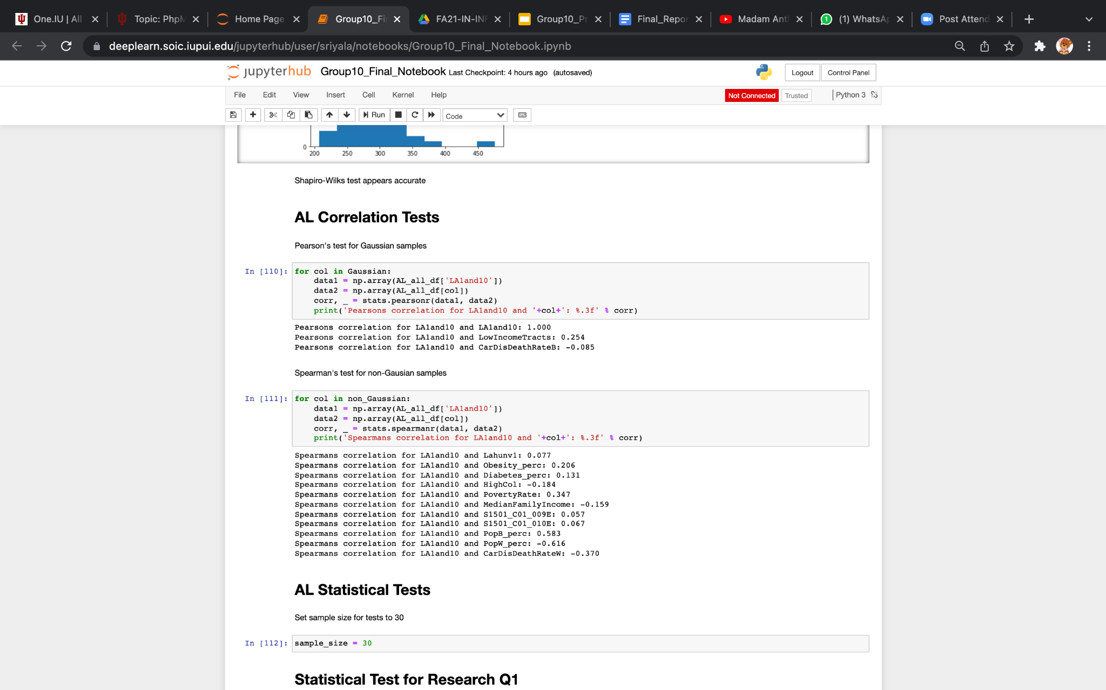

**Fig.18.** Code for Pearson's correlation test for Gaussian samples and Spearman’s correlation tes**t** for Non -Gaussian samples..

**STATISTICAL TESTS - ALABAMA**

We did an Unpaired T-test since LA1and10 is non-gaussian. We got different hypotheses for each of our research questions. We plotted Scatter plots to evaluate the percentage of food deserts

*Research Question1* : Are food deserts more prevalent in counties that have higher populations of minorities?

*Test Type:* Unpaired T-Test

*Test Result*:The amount of food deserts in primarily Caucasian counties is significantly different from the amount of food deserts in primarily African-American counties.

(P = 0.000, < 0.05 so null hypothesis is rejected)

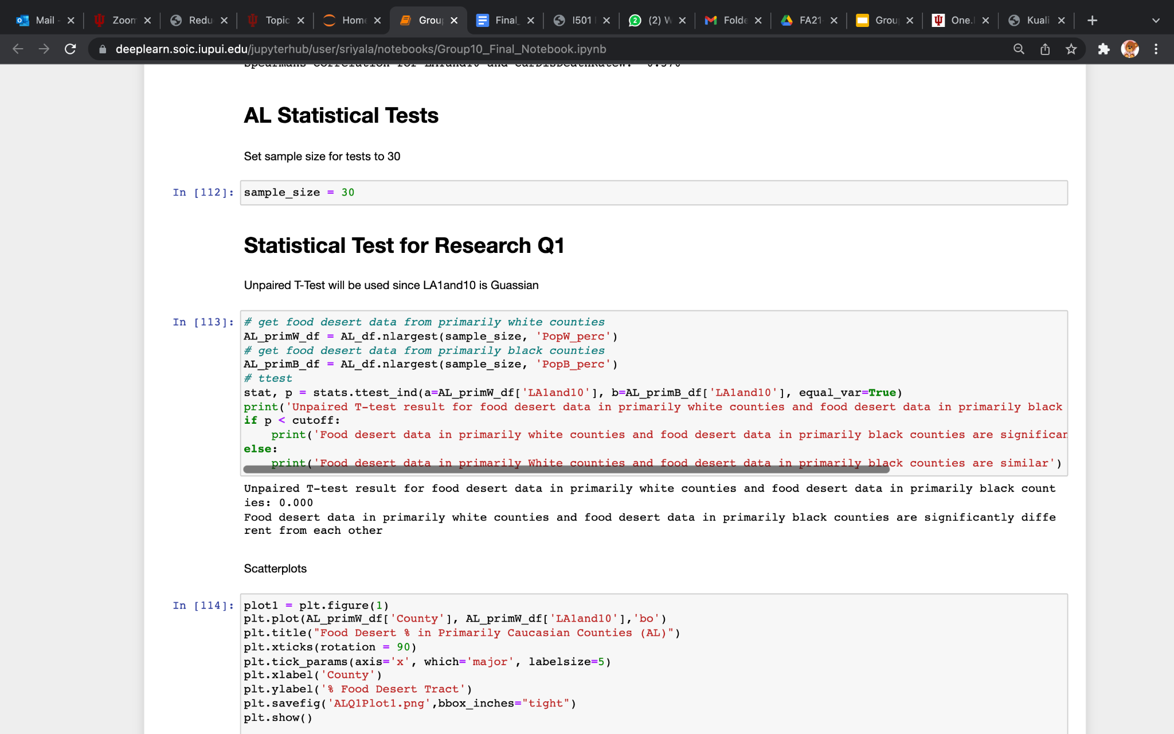

**Fig.19.** Code for Unpaired T-Test and result for research question 1.

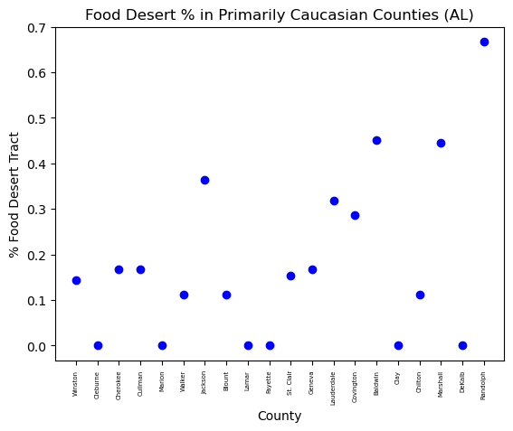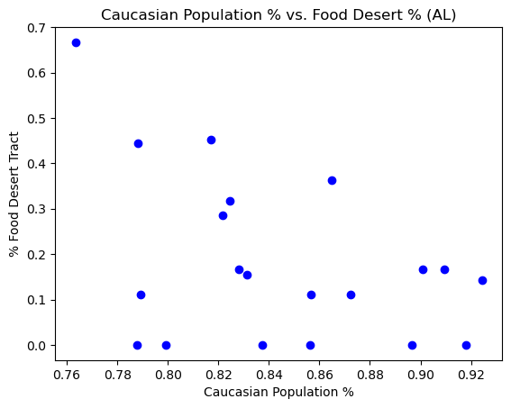

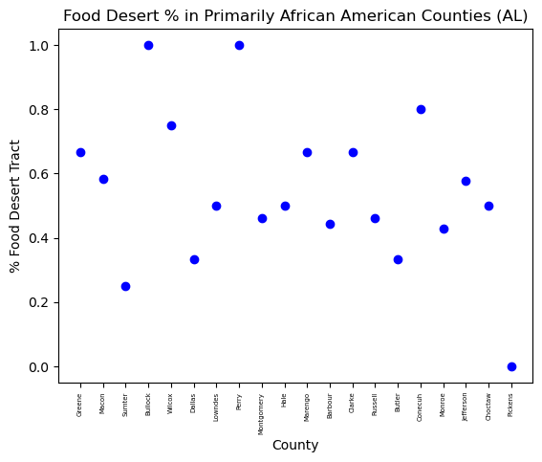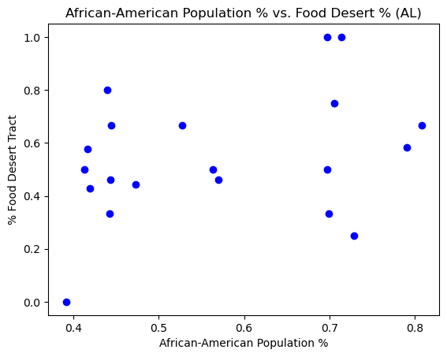

**Fig.20.** Scatter plot for %food desert vs %African American , Caucasian counties and populations.

*Research Question 2***:** Do food deserts result in higher percentages of people living with poor health conditions?

*Test Type*: Unpaired T-Test

*Test Result*:The amount of food deserts in counties with high percentages of high-cholesterol and diagnosed diabetes are similar to the amount in counties with low percentages of high-cholesterol and diagnosed diabetes.

(PDiabetes = 0.110, PHigh-Cholesterol = 0.409 > 0.05 so null hypothesis is not rejected)

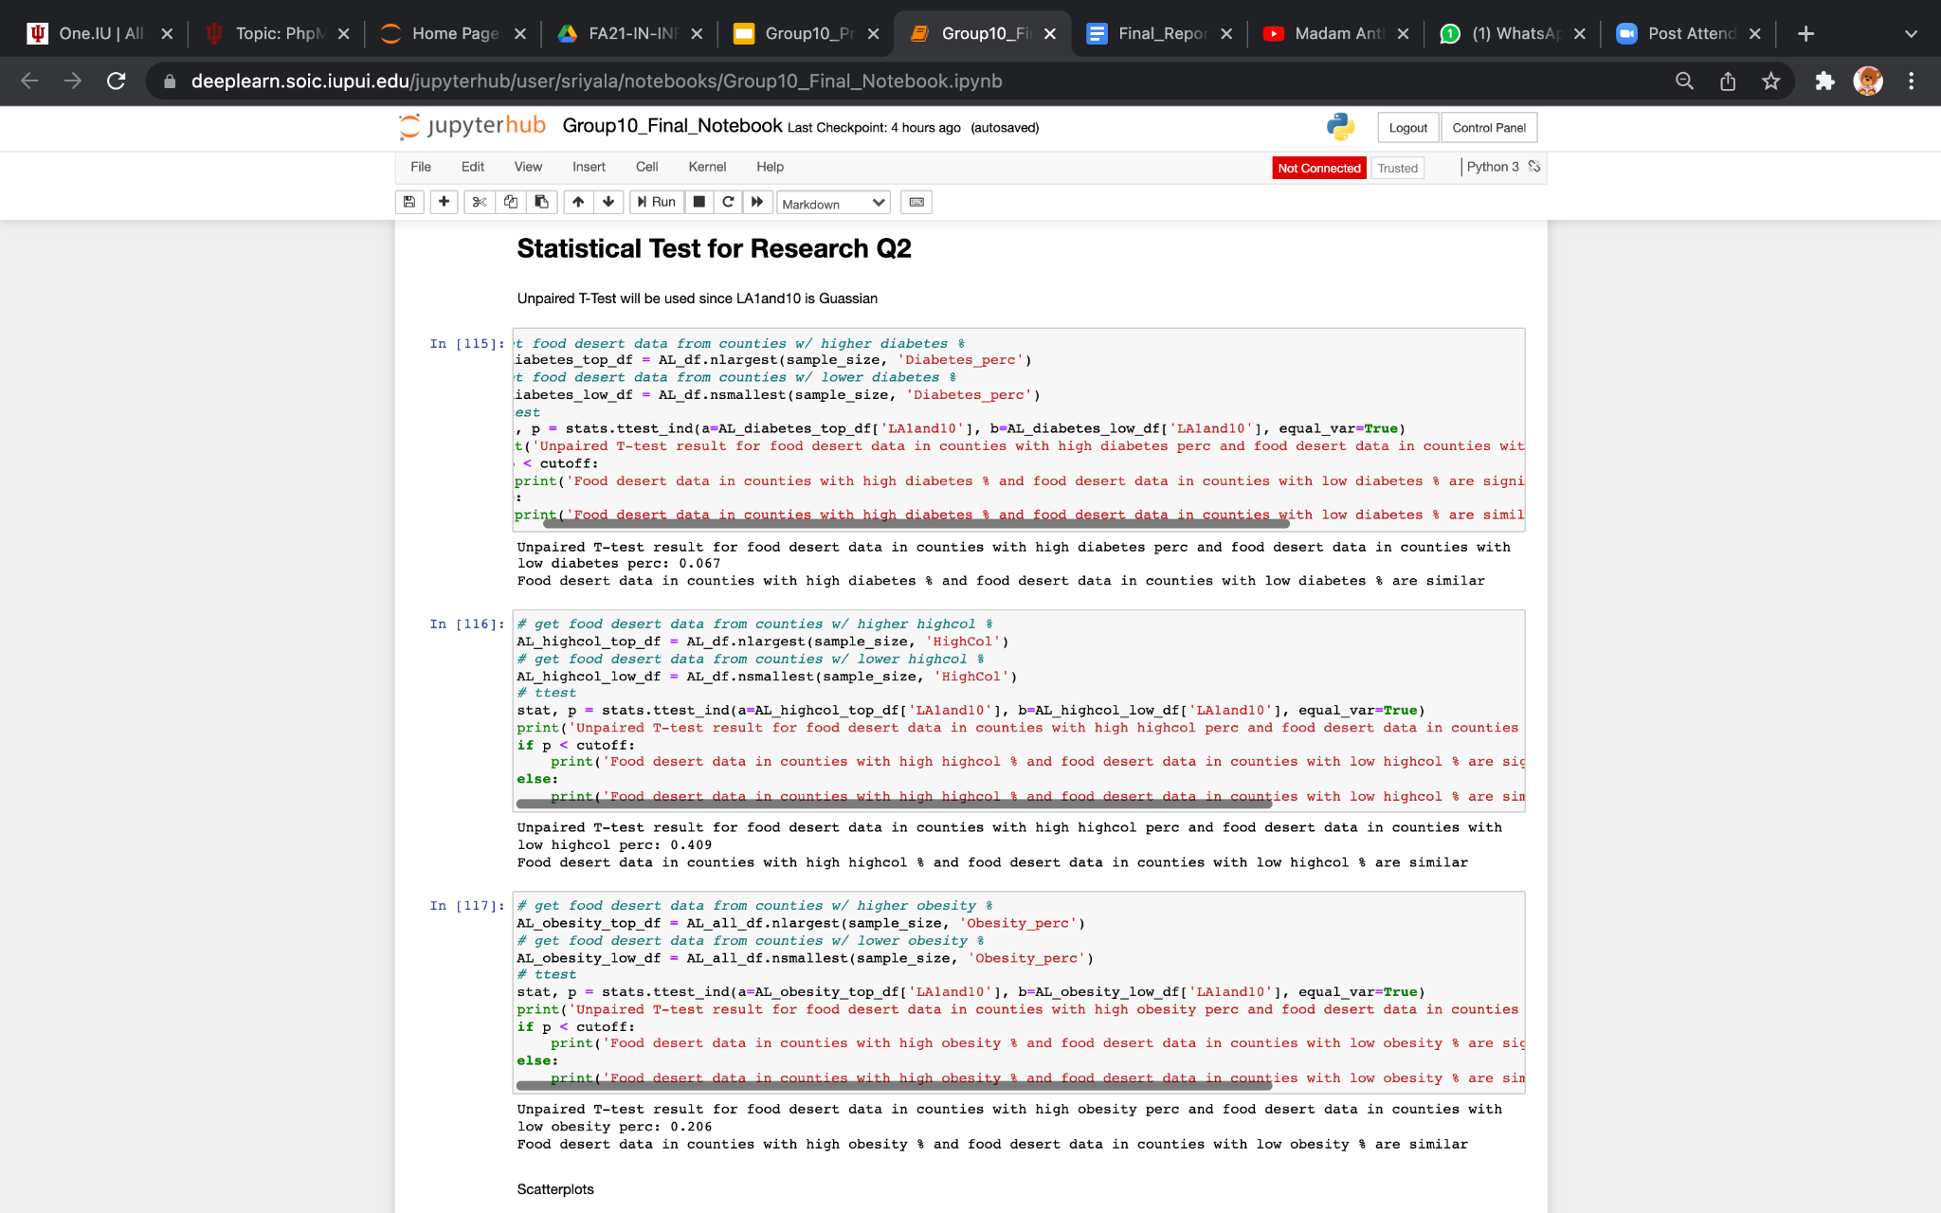

**Fig.21.** Code for Unpaired T-Test and results for research question 2

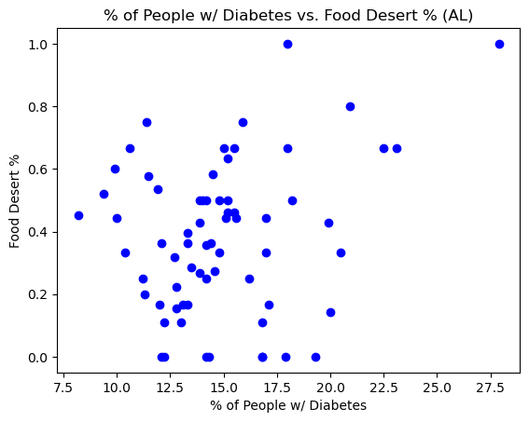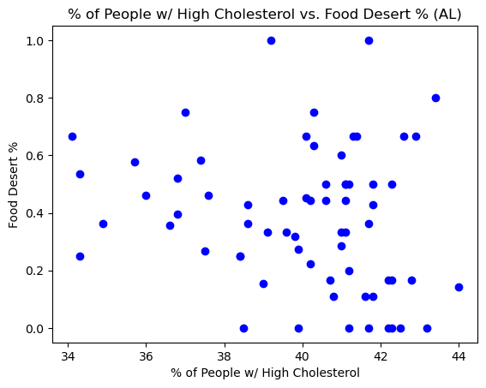

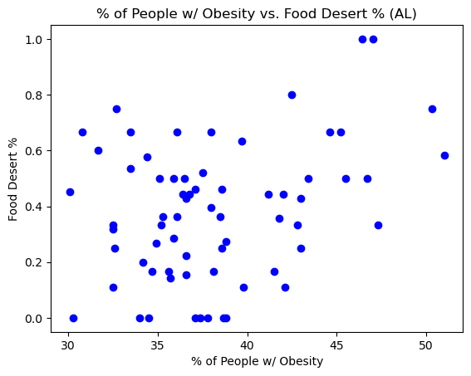

**Fig.22.** Scatter plots for food desert% vs % of people with diabetes, high cholesterol,obesity .

*Research Question* *3*: Does lacking a vehicle and living in a food desert increase risk of becoming unhealthy?

*Test Type*: Mann-Whitney U test

*Test Result*:The percentages of people living with obesity and high-cholesterol in counties that have more housing units without a vehicle is similar to the percentages of people living with obesity and high-cholesterol in counties that have less housing units without a vehicle.

(PObesity = 0.068, PHigh-Cholesterol = 0.057 > 0.05 so, null hypothesis is not rejected)

We performed Mann-Whitney U test in our third research question because the variable association we are trying to find are non-gaussian.

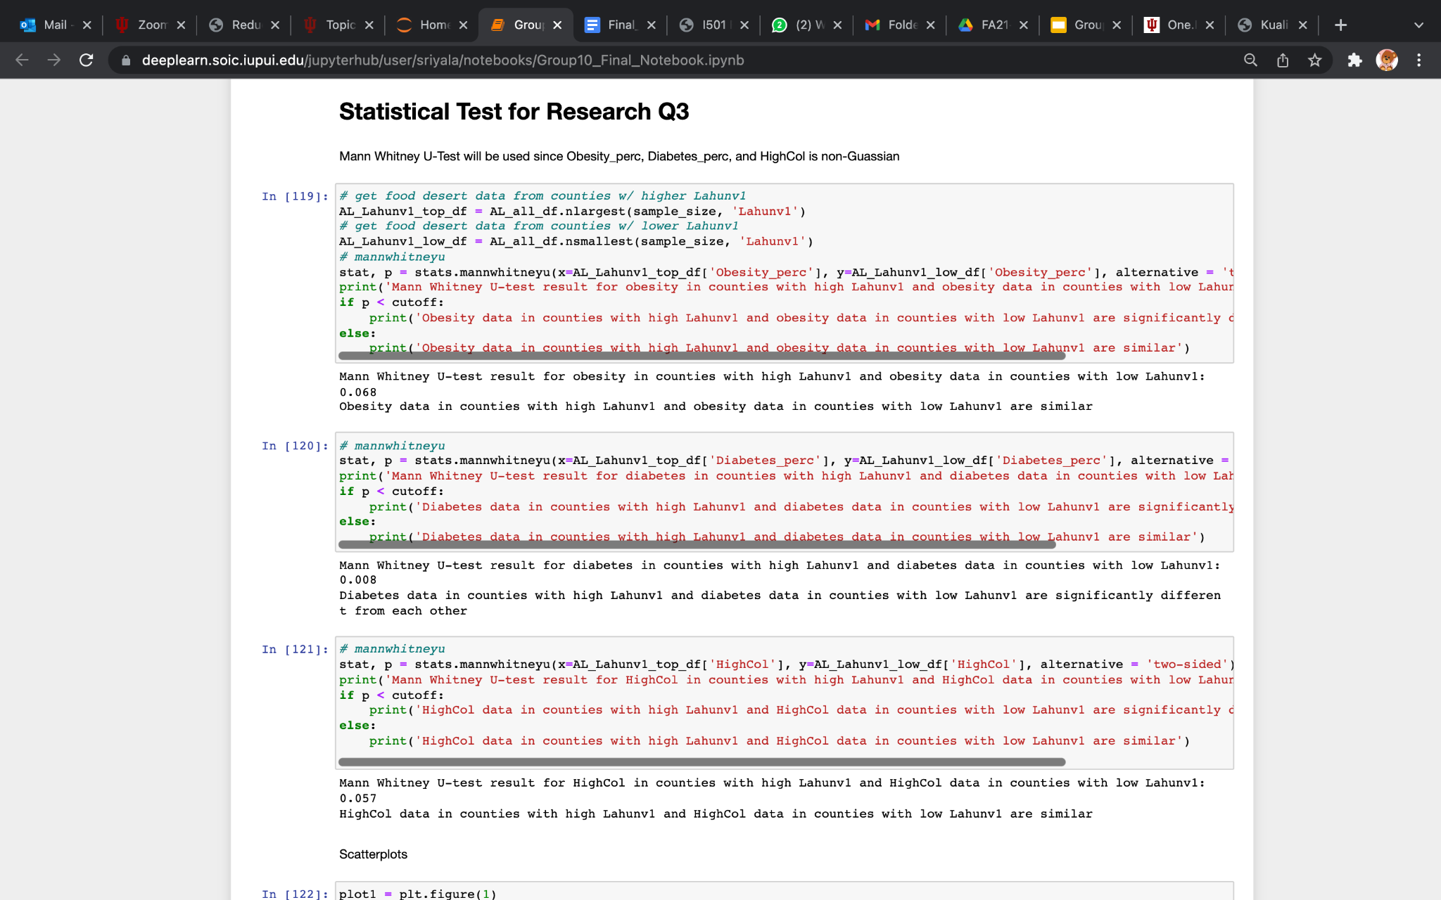

**Fig.23.** Code for Mann-Whitney U test and results for research question 3.

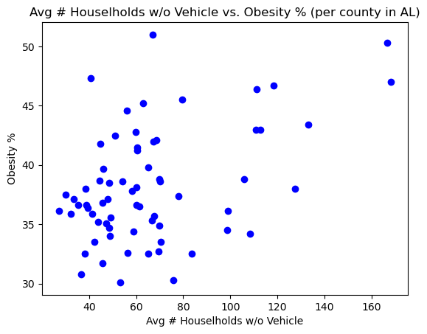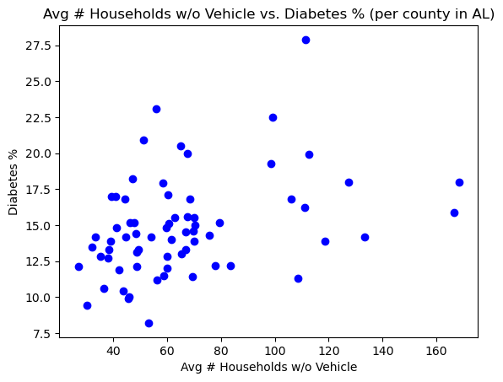

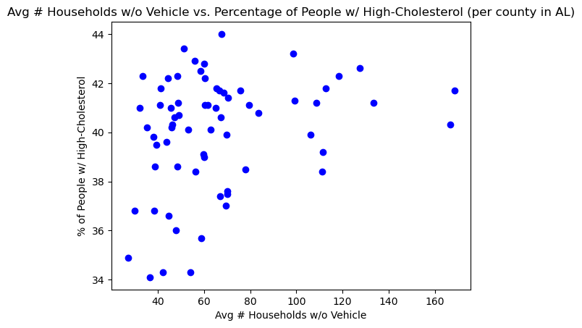

**Fig.24.** Scatter plots for % disease conditions (obesity, high cholesterol,diabetes) with avg # household w/o vehicle .

*Research Question 4*: Do people that live in low-income and high poverty rate communities have a greater chance of living in a food desert?

*Test Type*: Unpaired T-Test

*Test Result*:The amount of food deserts in counties with low poverty rates is significantly different from the amount of food deserts in counties with high poverty rates.

(P = 0.005 < 0.05 so null hypothesis is rejected)

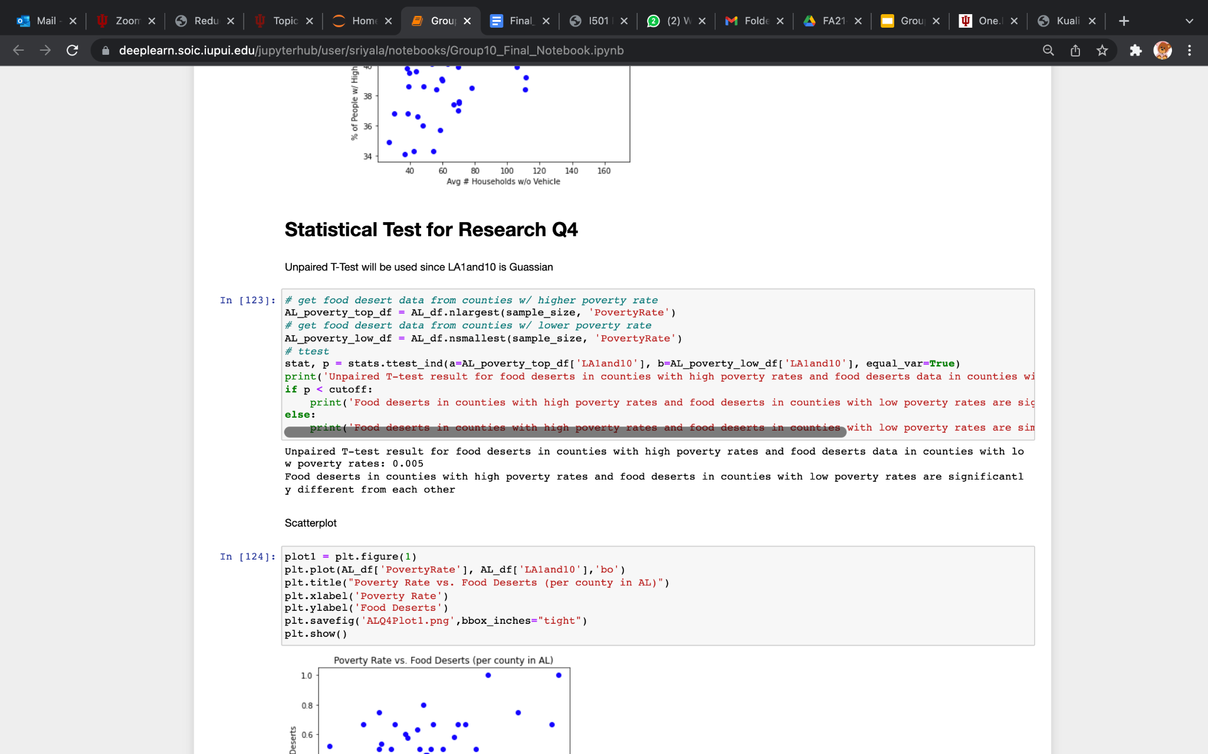

**Fig.25.** Code for Unpaired T-Test and results for research question 4.

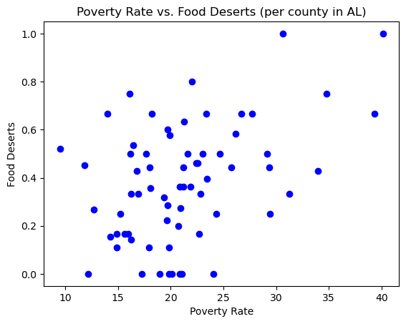 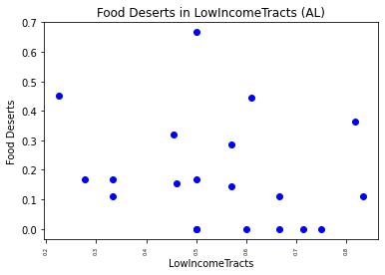

**Fig.26.** Scatter plots for food desert% with poverty rate and low income tracts.

Similarly we did a statistical test for Mississippi since it is in the top 5 sorted states after Alabama.

**7.2 MISSISSIPPI**

**MISSISSIPPI NORMALITY TEST**

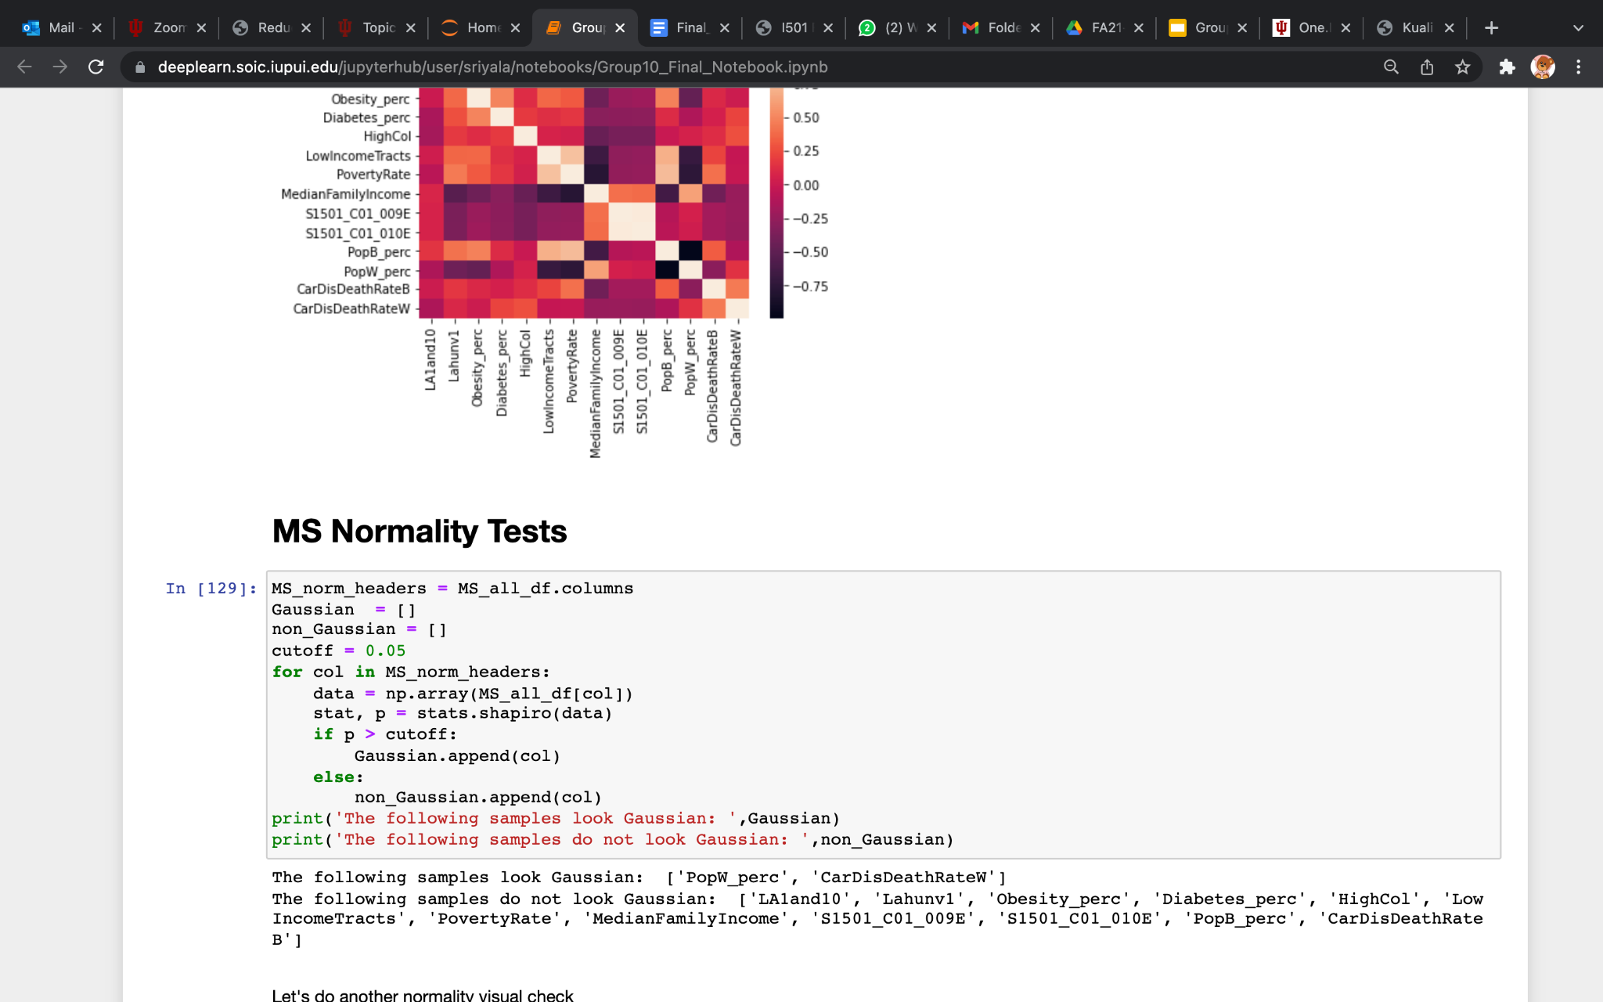

**Fig.26.** Code for Normality test.

**STATISTICAL TESTS - MISSISSIPPI**

***RESEARCH QUESTION 1:***

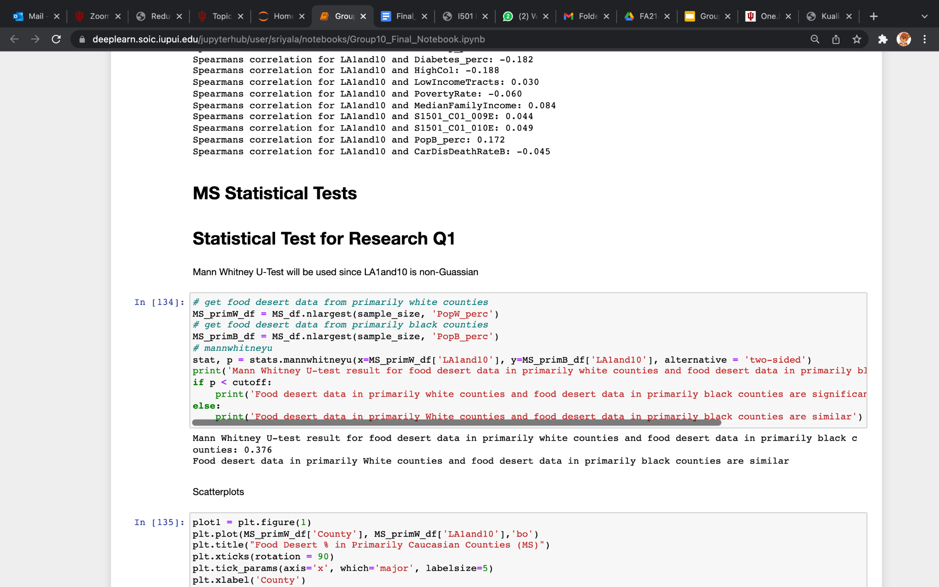

(P = 0.376, > 0.05 so null hypothesis is not rejected)

**Fig.27.** Code for Mann-Whitney U test and results for research question 1.

***RESEARCH QUESTION 2:***

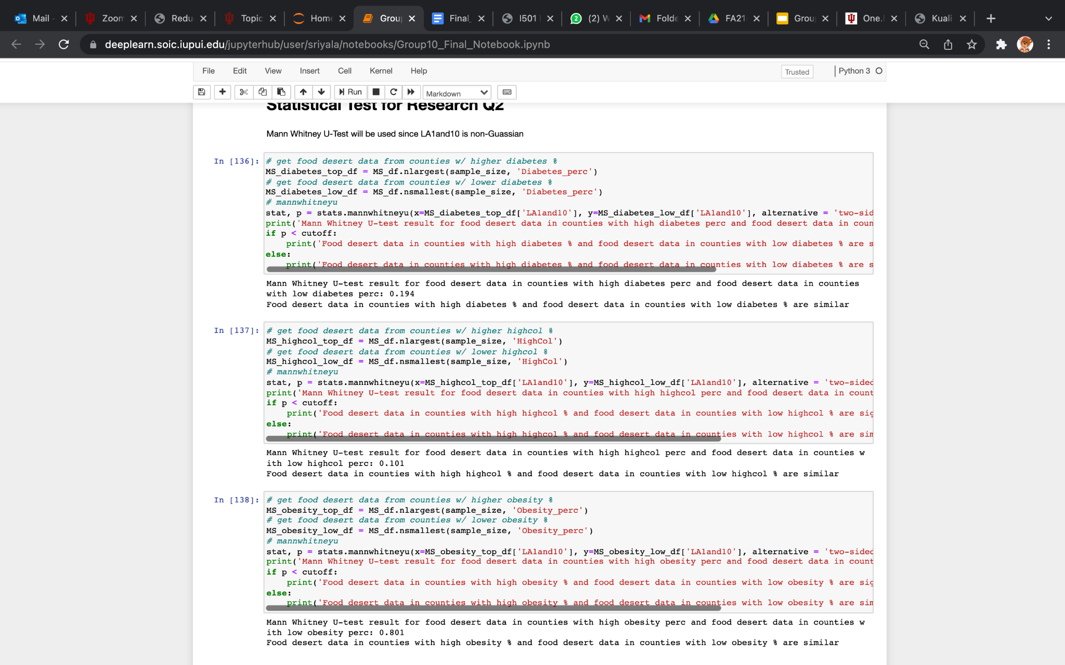

(PDiabetes = 0.194, PHigh-Cholesterol = 0.101 > 0.05 so, null hypothesis is not rejected)

**Fig.28.** Code for Mann-Whitney U test and results for research question 2.

***RESEARCH QUESTION 3:***

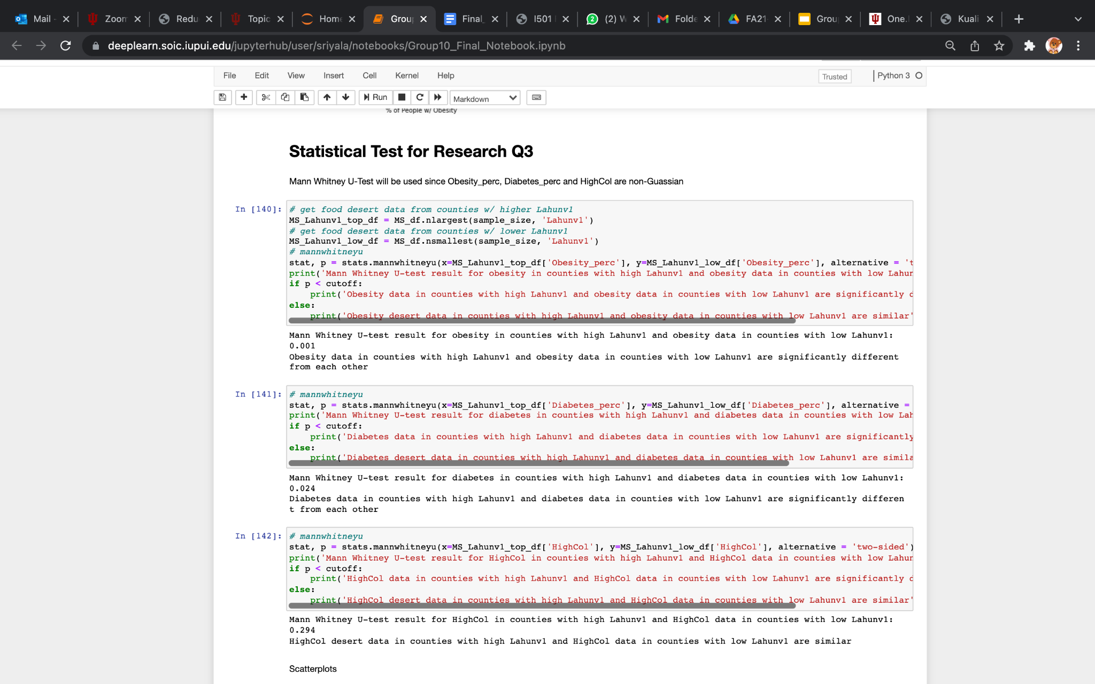

(PDiabetes = 0.024, PObesity = 0.001 < 0.05 so, null hypothesis is rejected)

**Fig.29.** Code for Mann-Whitney U test and results for research question 3.

***RESEARCH QUESTION 4:***

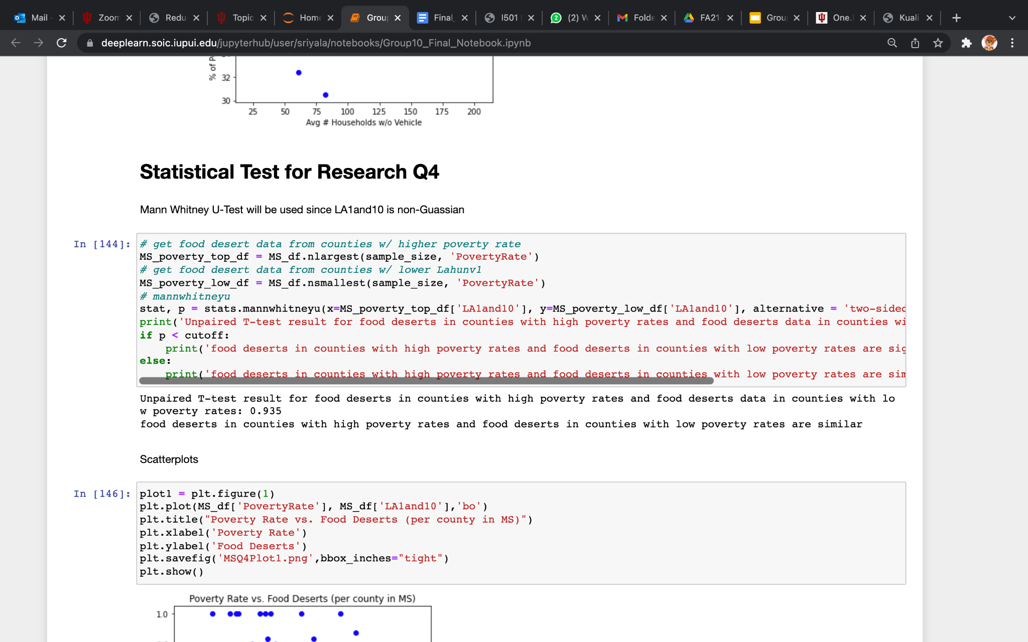

(P = 0.935 > 0.05 so, null hypothesis is not rejected)

**Fig.30.** Code for Mann-Whitney U test and results for research question 4.

**8 PREDICTIVE MODELING**

We created Machine Learning models that will allow us to predict what proportion of a county will be food deserted ,which is the dependent variable( LA1and10), given the independent features such as the poverty rate, median family income of the county, the number of low income tracts in the county, the percentage of people with obesity, diabetes, high cholesterol and cardiac disease, the proportion of african american , caucasian population of the county.

Since our Data is continuous and we want to predict a continuous value. Moreover, we have a regression problem and so we used regression models to predict our continuous variable LA1and10. We also scaled our independent features using Standard Scalar so that all our features lie on the same scale.

The following models are built and tested:

1. Linear Regression
2. K Nearest Neighbors Regressor
3. Decision Tree Regressor
4. Random Forest Regressor
5. Stochastic Gradient Descent Regressor
6. Gradient Boosting Regressor

The following evaluation metrics were measured for each models:

1. Mean Absolute Error (MAE)
2. Mean Squared Error (MSE)
3. Root Mean Squared Error (RMSE)
4. R2 Score

We created 3 types of models as follows:

1. A model which is built and tested on counties in all states.
2. A model which is built and tested on counties in low-performing states alone.
3. A model which is built and tested on counties in high-performing states alone.

We created a function called model_and_eval() which will take in the independent and dependent variables of the train and test datasets. It will then create and train the above-mentioned six regression models using the training data which is passed as arguments to the function and evaluate the model’s performance using the test data and the above-mentioned evaluation metrics. The function then returns the created models and the corresponding evaluation metric values of those models.

**8.1 LINEAR REGRESSION**

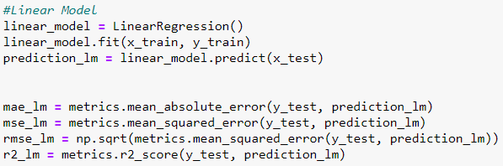

**Fig.31.** Code for Linear Regression

**8.2 K NEAREST NEIGHBORS REGRESSOR**

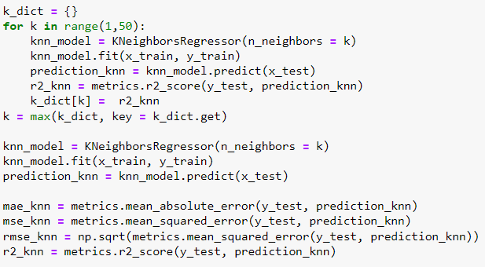

**Fig.32.** Code for K Nearest Neighbors Regressor.

**8.3 DECISION TREE REGRESSOR**

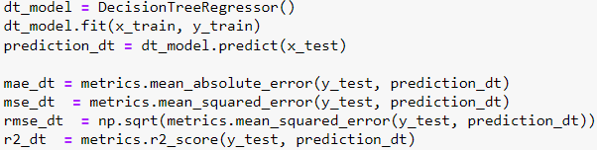

**Fig.33.** Code for Decision Tree Regressor

**8.4 RANDOM FOREST REGRESSOR**

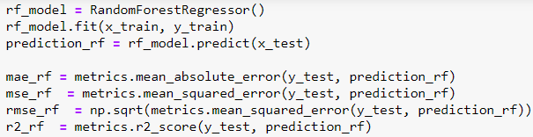

**Fig.34.** Code for Random forest Regressor

**8.5 STOCHASTIC GRADIENT DESCENT REGRESSOR**

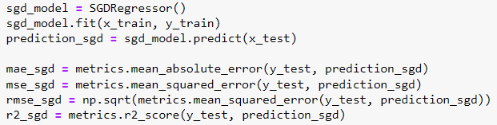

**Fig.35.** Code for Stochastic Gradient Descent Regressor

**8.6 Gradient Boosting Regressor**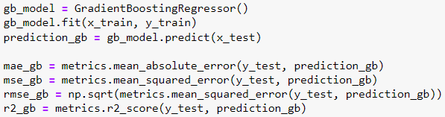

**Fig.36.** Code for Gradient Boosting Regressor

**A MODEL WHICH IS BUILT AND TESTED ON COUNTIES IN ALL STATES**

We created the training and testing dataset for this model by first dropping the categorical column ( StateID). We then separated the independent and dependent variables. From the original data frame we extracted the target variable and assigned it to a dataframe named Y. From the original data frame, we dropped the target variable and assigned it to a dataframe called X. We scaled our X dataframe containing the independent features using the fit_transform() function in the StandardScalar object. We then split our data into x_train, x_test, y_train and y_test using the train_test_split() function from model_selection in sklearn. We used 80% data for training and 20% data for testing.

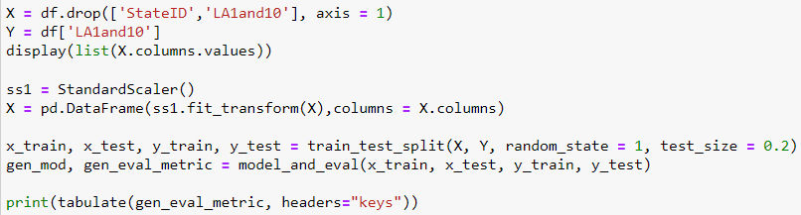

**Fig.37.** Code for training and testing data for counties in all states

After passing it to the function model_and_eval(), the evaluation metric obtained depicted in the following figure:

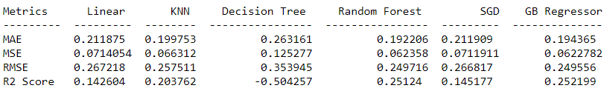

**Fig.38.**  Evaluation metrics for different regressors.

We will use the R2 score which is the Coefficient of determination that measures what proportion of the variance in the dependent variable is explained by the independent variables. Its range is from -1 to 1. R2 value close to 1 means that the model explains almost all the variance and it is a good model. A R2 value close to -1 signifies a poor model. From the R2 score in the above image, we can say that the Gradient Boosting Regressor performed better than all other models as its R2 value of 0.25 is higher than other models.

**MODEL WHICH IS BUILT AND TESTED ON COUNTIES IN LOW PERFORMING STATES ALONE**

In order to extract the counties in the low-performing or high performing states alone, we created a stateData function which retrieves the counties in a particular state. We identified 3 states - Alabama, Mississippi, and West Virginia as low-performing states and extracted the counties from the states into a combined dataframe, and then shuffled the combined dataframe. We separated the independent and dependent variables into X and Y dataframes and split them into x_train, x_test, y_train and y_test using the train_test_split() function.

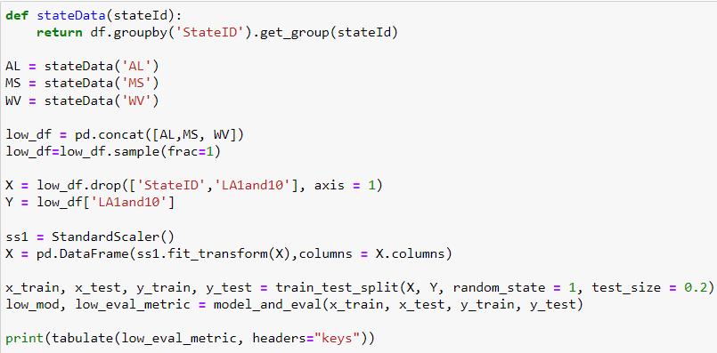

**Fig.39.** Code for training and testing data for counties in low performing states alone .

After passing it to the function model_and_eval(), the evaluation metric obtained depicted in the following figure,

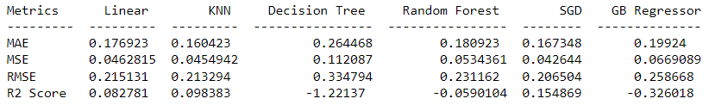

**Fig.40.**  Evaluation metrics for different regressors for low performing states .

From the figure, we can conclude that the Stochastic Gradient Descent Regressor with an R2 score of 0.15 is the best compared to other models.

**MODEL WHICH IS BUILT AND TESTED ON COUNTIES IN HIGH PERFORMING STATES ALONE**

We extracted the counties of Georgia, California and Indiana as the counties of high-performing states. We combined them into a single data frame using the pd.concat() function and shuffled them using df.sample(). We separated the independent and dependent variables into X and Y data frames and split them into 80% training and 20% testing datasets using the train_test_split() function.

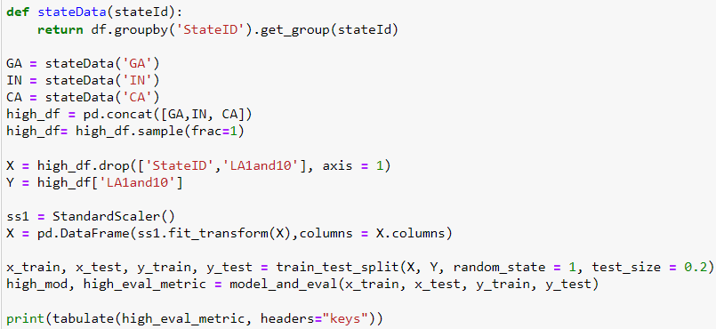

**Fig.40.** Code for training and testing data for counties in high performing states alone.

After passing it to the function model_and_eval(), the evaluation metric obtained depicted in the following figure

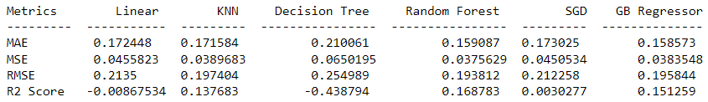

**Fig.41.**  Evaluation metrics for different regressors for high performing states .

We can see that the Random Forest regressor with R2 score of 0.16 performs well in comparison with the other models.

In general, the general model built on data from counties in all the states perform better than the state performance specific models according to their R2 scores.

The evaluation metrics might change each time the program is run due to the randomization provided by the shuffle function and the train_test_split().

**9 CONCLUSIONS**

Two of our research questions were accepting null hypothesis while the other two research questions were rejecting null hypothesis for Alabama State. From this, we interpret that food deserts are influenced by minority populations and socioeconomic factors while not having any significant impact on health conditions in Alabama. Also, transportation facilities in food deserts do not influence health conditions in Alabama. While for Mississippi, food desserts doesn't have any impact on minority population, health conditions and socioeconomic factors. The transportation facilities in food deserts do influence health conditions in Mississippi. From our predictions, we interpret that food deserts' impact on various factors differs from one state to another state. From our model R2 scores, Stochastic Gradient Descent Regressor have a better value , though the value is not accurate enough, for low-performing states. Gradient Boost Regressor was found to perform better model analysis for counties in all the states and Random Forest Regressor for high performing states.

**10 LIMITATIONS**

We tried to overcome the possible limitations, but since this is our first project working together we did encounter a few of them. The accuracy values for the models we performed were not accurate enough. Addition of further information like more health related diseases and the data that is available during the pandemic will be useful since a lot has changed during the pandemic. Another limitation was how little correlation existed within our data. We believe part of the problem is that the states with the most food deserts are mountainous states in the north western part of the U.S. where people live spread out from each other. These states also have relatively healthy populations. This caused us to focus on states that have more urban counties and counties that appear more unhealthy.

**A APPENDIX**

**A.1** **Data Guide** *Tract = section of a county

| `ID` | Index |
| --- | --- |
| `County` | US county |
| `StateID` | US State abbreviation |
| `LA1and10` | Avg flag value for low access tract at 1 mile for urban areas and 10 miles for rural areas per county (2019) |
| `LAhalfand10` | Avg flag value for low access tract at 1/2 mile for urban areas and 10 miles for rural areas per county (2019) |
| `LA1and20` | Avg flag value for low access tract at 1 mile for urban areas and 20 miles for rural areas per county (2019) |
| `LowIncomeTracts’ | Avg flag value for low-income tract per county (2019) |
| `PovertyRate` | Avg share of the tract population living with income at or below the Federal poverty thresholds for family size per county (2019) |
| `MedianFamilyIncome’ | Avg median family income per county (2019) |
| `Lahunv1` | Avg share of housing units that are without vehicle and beyond 1 mile from supermarket per county (2019) |
| `Lahunv10` | Avg share of housing units that are without vehicle and beyond 10 miles from supermarket per county (2019) |
| `Lahunv20` | Avg share of housing units that are without vehicle and beyond 20 miles from supermarket per county (2019) |
| `Obesity_perc` | Obesity, Age-Adjusted Percentage, 20+, 2017 per county |
| `Diabetes_perc` | Diagnosed Diabetes, Age-Adjusted Percentage, 20+, 2017 per county |
| `HighCol` | High Cholesterol Among Adults Screened in Past 5 Years Aged 18+, 2017 per county |
| `CarDisDeathRateB’ | Total Cardiovascular Disease Death Rate per 100,000, All Ages, Black (Non-Hispanic), Both Genders, 2017-2019 per county |
| `CarDisDeathRateH’ | Total Cardiovascular Disease Death Rate per 100,000, All Ages, Hispanic, Both Genders, 2017-2019 per county |
| `CarDisDeathRateW’ | Total Cardiovascular Disease Death Rate per 100,000, All Ages, White (Non-Hispanic), Both Genders, 2017-2019 per county |
| `TotalPop` | Total population of one race (2020) |
| `TotalPopW` | Total population of one race: White alone (2020) |
| `TotalPopB` | Total population of one race: Black alone (2020) |
| `S1501_C01_001E` | Population 18 to 24 years (2019) |
| `S1501_C01_002E` | Population 18 to 24 years: Less than high school graduate (2019) |
| `S1501_C01_003E` | Population 18 to 24 years: High school graduate (includes equivalency) (2019) |
| `S1501_C01_004E` | Population 18 to 24 years: Some college or associate's degree (2019) |
| `S1501_C01_005E` | Population 18 to 24 years: Bachelor's degree or higher (2019) |
| `S1501_C01_006E` | Population 25 years and over: Less than 9th grade (2019) |
| `S1501_C01_008E` | Population 25 years and over: 9th to 12th grade, no diploma (2019) |
| `S1501_C01_009E` | Population 25 years and over: High school graduate (includes equivalency) (2019) |
| `S1501_C01_010E` | Population 25 years and over!!Some college, no degree (2019) |

**A.2** **SQL code to create our table**

-- MySQL dump 10.13 Distrib 5.1.51, for pc-linux-gnu (i686)

--

-- Host: 127.0.0.1 Database: I501Fa21grp10_db

-- ------------------------------------------------------

-- Server version 5.1.51-debug-log

/*!40101 SET @OLD_CHARACTER_SET_CLIENT=@@CHARACTER_SET_CLIENT */;

/*!40101 SET @OLD_CHARACTER_SET_RESULTS=@@CHARACTER_SET_RESULTS */;

/*!40101 SET @OLD_COLLATION_CONNECTION=@@COLLATION_CONNECTION */;

/*!40101 SET NAMES latin1 */;

/*!40103 SET @OLD_TIME_ZONE=@@TIME_ZONE */;

/*!40103 SET TIME_ZONE='+00:00' */;

/*!40014 SET @OLD_UNIQUE_CHECKS=@@UNIQUE_CHECKS, UNIQUE_CHECKS=0 */;

/*!40014 SET @OLD_FOREIGN_KEY_CHECKS=@@FOREIGN_KEY_CHECKS, FOREIGN_KEY_CHECKS=0 */;

/*!40101 SET @OLD_SQL_MODE=@@SQL_MODE, SQL_MODE='NO_AUTO_VALUE_ON_ZERO' */;

/*!40111 SET @OLD_SQL_NOTES=@@SQL_NOTES, SQL_NOTES=0 */;

SET AUTOCOMMIT=0;

--

-- Table structure for table `Food_desert_data`

--

DROP TABLE IF EXISTS `Food_desert_data`;

/*!40101 SET @saved_cs_client = @@character_set_client */;

/*!40101 SET character_set_client = utf8 */;

CREATE TABLE `Food_desert_data` (

`ID` INT(11) NOT NULL AUTO_INCREMENT,

`County` CHAR(35) NOT NULL DEFAULT '',

`StateID` CHAR(3) NOT NULL DEFAULT '',

`LA1and10` DECIMAL(12,4) NULL DEFAULT '0',

`LAhalfand10` DECIMAL(12,4) NULL DEFAULT '0',

`LA1and20` DECIMAL(12,4) NULL DEFAULT '0',

`LowIncomeTracts` DECIMAL(12,4) NULL DEFAULT '0',

`PovertyRate` DECIMAL(12,4) NULL DEFAULT '0',

`MedianFamilyIncome` DECIMAL(12,2) NULL DEFAULT '0',

`Lahunv1` DECIMAL(12,4) NULL DEFAULT '0',

`Lahunv10` DECIMAL(12,4) NULL DEFAULT '0',

`Lahunv20` DECIMAL(12,4) NULL DEFAULT '0',

`Obesity_perc` DECIMAL(12,1) NULL DEFAULT '0',

`Diabetes_perc` DECIMAL(12,1) NULL DEFAULT '0',

`HighCol` DECIMAL(12,1) NULL DEFAULT '0',

`CarDisDeathRateB` DECIMAL(12,1) NULL DEFAULT '0',

`CarDisDeathRateH` DECIMAL(12,1) NULL DEFAULT '0',

`CarDisDeathRateW` DECIMAL(12,1) NULL DEFAULT '0',

`TotalPop` INT NULL DEFAULT '0',

`TotalPopW` INT NULL DEFAULT '0',

`TotalPopB` INT NULL DEFAULT '0',

`S1501_C01_001E` INT NULL DEFAULT '0',

`S1501_C01_002E` INT NULL DEFAULT '0',

`S1501_C01_003E` INT NULL DEFAULT '0',

`S1501_C01_004E` INT NULL DEFAULT '0',

`S1501_C01_005E` INT NULL DEFAULT '0',

`S1501_C01_006E` INT NULL DEFAULT '0',

`S1501_C01_008E` INT NULL DEFAULT '0',

`S1501_C01_009E` INT NULL DEFAULT '0',

`S1501_C01_010E` INT NULL DEFAULT '0',

PRIMARY KEY (`ID`),

KEY `County` (`County`)

) ENGINE=InnoDB AUTO_INCREMENT=4080 DEFAULT CHARSET=latin1;

/*!40101 SET character_set_client = @saved_cs_client */;

**A.3** **Screenshot of the Food_Desert table**

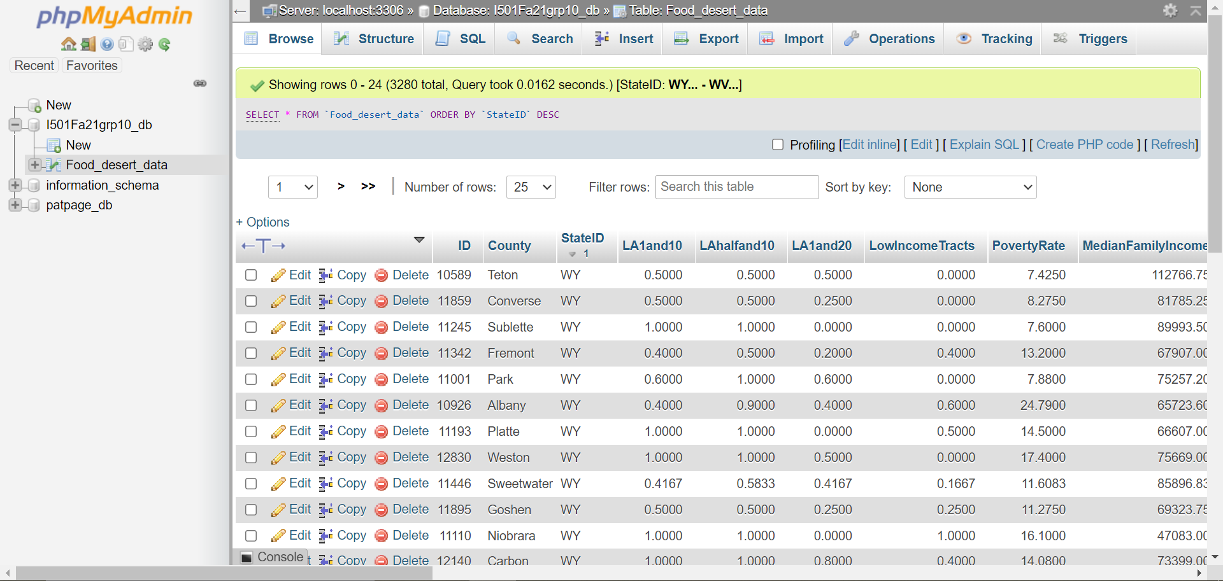

**REFERENCES**

1. *Food deserts\**. Food Empowerment Project. (n.d.). Retrieved September 19, 2021, from https://foodispower.org/access-health/food-deserts/.
2. Economic Research Service (ERS), U.S. Department of Agriculture (USDA). [Food Access Research Atlas](https://www.ers.usda.gov/data-products/food-access-research-atlas/), <https://www.ers.usda.gov/data-products/food-access-research-atlas/>
3. Centers for Disease Control and Prevention. Interactive Atlas of H72eart Disease and Stroke. <http://nccd.cdc.goc/DHDSPAtlas>. Accessed on September 19, 2021
4. Bureau, U. S. C. (2021, October 8). *2021 annual social and economic supplements*. Census.gov. Retrieved December 17, 2021, from https://www.census.gov/data/datasets/2021/demo/cps/cps-asec-2021.html
5. Explore census data. (n.d.). Retrieved December 17, 2021, from <https://data.census.gov/cedsci/table?q=education&t=Age+and+Sex%3AEducational+Attainment%3APopulations+and+People&g=0100000US%240500000&tid=ACSST1Y2019.S1501>